Revision History
Revision | Description of Change | Revision date
1.0 | Test report phase1 and phas2 | 2018-08-13
2.0 | Test report phase3 | 2018-08-17

TABLE OF CONTENTS

Introduction 3
1 Test Object 3
2 Test Environment 5
3 Testing work （Phase 1） 6
3.1 Test Environment 6
3.2 Test scenario and strategy 7
3.3 Test Tool 7
3.4 Database setting 7
3.5 IIS setting 8
3.6 Test Object version 8
3.7 Background data 8
3.8 Test Conclusion 9
3.9 Suggestion 9
4 Testing work （Phase 2） 10
4.1 Test Environment 10
4.2 Test scenario and strategy 10
4.3 Test Tool 11
4.4 Database setting 11
4.5 IIS setting 11
4.6 Test Object version 11
4.7 Background data 12
4.8 Test Error 13
4.9 Test result of PS server 13
Test result of PS transactions 13
Test Statistic Report of PS 14
Transaction summary result of PS 15
Transaction response time result of PS 15
4.10 Test result of Web service 17
Test result of web transactions 17
Test Statistic Report of Web 17
Transaction summary result of Web 19
Transaction response time result of Web 19
4.11 Performance bottleneck analysis 21
Hardware usage analysis 21
SQL Server resource usage analysis 25
4.12 Test Conclusion 28
5 Testing work （Phase 3） 29
5.1 Test Environment 29
5.2 Test scenario and strategy 29
5.3 Test Tool 30
5.4 Database setting 30
5.5 IIS setting 30
5.6 Test Object version 30
5.7 Background data 30
5.8 Test Error 31
5.9 Test result of PS server 32
Test result of PS transactions 32
Test Statistic Report of PS 33
Transaction summary result of PS 34
Transaction response time result of PS 34
5.10 Test result of Web service 35
Test result of web transactions 36
Test Statistic Report of Web 36
Transaction summary result of Web 38
Transaction response time result of Web 38
5.11 Performance bottleneck analysis 40
Hardware usage analysis 40
SQL Server resource usage analysis 44
5.12 Test Conclusion 48
5.13 Tune suggestion: 49

Introduction
The PUMA performance testing works will focus on main work flow of the Print Server of Kiosk (PS).
The PUMA PS system will integrated with other 3rd systems like HIS, RIS, LIS etc. System will synchronize 3rd party data and provide the film and report printing services. The Cloud Film system will integrate with PS and get the patient information and images data from PS system.
We should confirm the performance of PS system will meet the requirements on real work environments. Ensure the images upload service of Cloud Film will not affect main workflow of PS system.

Test Object
The PUMA system will support film and report printing and notice push service for different departments of entire hospital.
We will integrate the 3rd party system and patients can print their reports in ONE terminal. The message push service will also be included in the product. Patients can query different information, and get report status notice service from the product.
PUMA MR1 system will provide the patient images data upload service for Cloud Film system. The patient can view the image files including picture and DICOM type from WeChat platform or by scanning from 2D image code.
The architecture as follow:

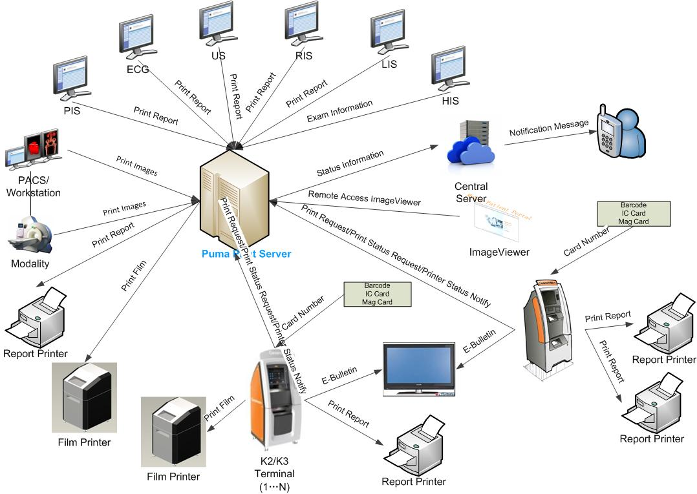Figure 3.1.2

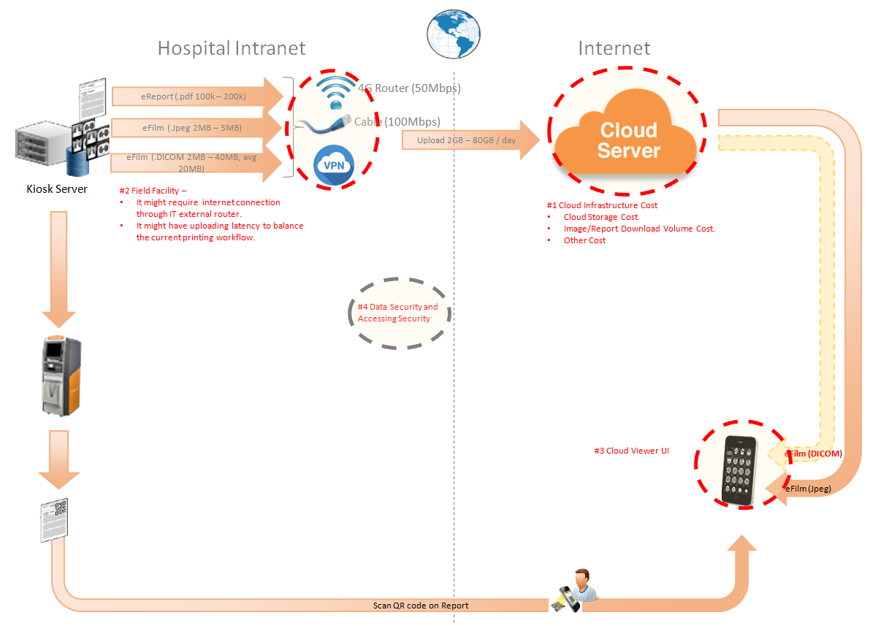Figure 3.1.2
The performance testing work will focus on the PS system. We will simulate the web service call and send them to PS server, and monitor the transactions response time, service performance and hardware resource usage. This scenario will include the 3rd request, report archived, film and report print, image files upload and web query, update operations etc.

Test Environment
The detailed hardware configurations of all servers are described as follow:

Computer name | CPU | Memory | HD | OS | Other | Comments
PS Server Panda upgrade | Interl(R) Xeon® CPU E5-2350 @ 1.80 * 6 | 16GB | 1TB | Windows 2008 R2 64bit | SQL server workgroup 2008 | Limit the local net width to 20MBps.
Workstation Server | Intel i3-2120 3.3GHz | 2GB | 80GB | Windows 7 SP1 64bit | QTP 11 | 6 virtual machine in server
Terminal | Intel Atom D525 1.8GHz | 4GB | 450GB | Windows Embedded Standard SP1 64bit | UTF 12.0 trail
Cloud Film Server | Interl(R) Xeon® CPU E5-2620 @ 2.40 * 6 | 64GB | 1T | Windows server2016 Standard 64 bit | Mock server from develop
Cloud film DB Server | Interl(R) Xeon® CPU E5-2620 @ 2.40 * 6 | 64GB | 1T | Windows server2016 Standard 64 bit | Mysql 5.6

Table 1 Hardware Configuration

Testing work （Phase 1）

Test Environment
The detailed hardware configurations of all servers are described as follow:

Computer name | CPU | Memory | HD | OS | Other | Comments
PS Server Panda upgrade | Interl(R) Xeon® CPU E5-2350 @ 1.80 * 6 | 16GB | 1TB | Windows 2008 R2 64bit | SQL server workgroup 2008 | Limit the local net width to 20MBps.
Workstation Server | Intel i3-2120 3.3GHz | 2GB | 80GB | Windows 7 SP1 64bit | QTP 11 | 6 virtual machine in server
Terminal | Intel Atom D525 1.8GHz | 4GB | 450GB | Windows Embedded Standard SP1 64bit | UTF 12.0 trail
Cloud Film Server | Interl(R) Xeon® CPU E5-2620 @ 2.40 * 6 | 64GB | 1T | Windows server2016 Standard 64 bit | Mock server from develop
Cloud film DB Server | Interl(R) Xeon® CPU E5-2620 @ 2.40 * 6 | 64GB | 1T | Windows server2016 Standard 64 bit | Mysql 5.6

Table 1 Hardware Configuration

Test scenario and strategy
Virtual User: 21 Users
Duration: 8 hour
Description: Use the test tool simulates the patient operations. Monitor the server software and hardware resource usage. The detail information as follow:
- Use automation tool simulate the doctor print film work. Simulate 6 GX Platform by using QTP and WinDPSTester tool. Each client prints one film which size is 10MB every 30 seconds.
- Use LR tool simulate 8 K2/K3 terminals to print film. Each client prints one film which size is 10MB random 5 to 30 seconds.
- Use LR tool simulate 8 users to do report archive operations. Each client archive report in random 5 to 30 seconds and size is random with 100kb and 4Mb.
- Use LR tool simulate 8 terminals to print paper reports. Each client prints report random 5 to 30 seconds.
- The OCR setting is not has rule for GX platforms in step1 and other setting are set as default. The OCR service will under the strong stress without configure the rule.
- Simulate 5 users to do the query information, view monitor page, query reconciliation films and report, expand the record, change the status, set holding time and other operations in worklist.
- Monitor the transaction response time.
- Monitor the hardware resource usage on PS.
- Monitor the resource usage for database on PS.
- Start/Stop 2 virtual users every 10 seconds and run the scenario for 8 hours.
- Simulate the Upload network bandwidth to 20M.

Note:
We will do the performance testing work under big stress for system. If system can work well under current stress and the transaction process ability meets the requirement, we will give the conclusion the system performance is pass.

Test Tool
Load Runner 12.

Database setting
Memory: Set the min and max memory size to 4GB.
Index fill factor: 80.
File: Increase the data and log files size and the rule is increase 200Mb as fixed size.

IIS setting
Connection: Set the max connection value to 4000 and keep other setting as default.

Test Object version
KIOSK cloud film 3.0.3.0 B23

Background data
We prepared a background records in the PS system. The data size is calculated by the typical site which printed 3,000 films in a workday. That means the records of films in db should more than 972,000 (3000records / day *54 weeks * 6 workday). QA team had prepared these data with SQL script and automation script. These data can backup and import by DB tool.
The detail data records in DB as follow:

Table Name | Data Volume (records)
printer.dbo.DeliveryJob | 995199
printer.dbo.ImageBox | 3530116
printer.dbo.Page | 314893
printer.dbo.Session | 571212
wggc.dbo.Patient | 1224710
wggc.dbo.Study | 1434574
wggc.dbo.AFP_PrintTerminalInfo | 70
wggc.dbo.Series | 1434524
wggc.dbo.Image | 1434527
wggc.dbo.AFP_FilmInfo | 1420905
wggc.dbo.AFP_ReportInfo | 1232003
wggc.dbo.AFP_ExamInfo | 2308723
wggc.dbo.AFP_PrintTask | 4324918
wggc.dbo.T_Integration_ExamInfo | 1421769
AFP_PrintMode | 523684
wggc.dbo.vi_KIOSK_ExamInfo_Order | 838208

Test Conclusion
The develop team offer a mock service and QA team limit the net width to 20Mbps. The system performance does not meet the requirements of design. The DICOM and report upload operation cannot work well and some issues exist in the database. The detail information as follow:
- The upload file queue will block if the queue is more than default value. It cause by the SQL statement in the database.
- The ACQ service will cause the database locks if script try to insert patient information to table patient in database wggc.
- The patient report will not upload if patient only has report because the patient has not patient information in database. The patient information will create when their image archived in system.
- The patient information created will failed when the patient age has character like “YMD” in DICOM files. Need change the column property in database.

QA team had submitted the defects in PLI to record these issues:
Event Number | Title
100048496 | [Performance] The upload queue will block when maxuploadfile value more than default one.
100048495 | [Performance]There are table lock issue exist in the database for acq service of PS.
100048438 | [Cloud Film]The patient report will not upload if patient only has report.
100048437 | [Cloud Film] The column patientage type should not be int in ECS and CS database .

Suggestion

- Fix the defects which had submitted by QA team.
- Enhance the SQL statement of “wggc.dbo.AFP_SP_GetExamsForSyncToECS”. This store procedure is the root reason of defect 10048496.
- Change the design of files upload logic. Reduce the number of upload thread. The reliability of service is important than the performance for our system.

Testing work （Phase 2）

Test Environment
The detailed hardware configurations of all servers are described as follow:

Computer name | CPU | Memory | HD | OS | Other | Comments
PS Server Panda upgrade | Interl(R) Xeon® CPU E5-2350 @ 1.80 * 6 | 16GB | 1TB | Windows 2008 R2 64bit | SQL server workgroup 2008 | Limit the local net width to 20MBps.
Workstation Server | Intel i3-2120 3.3GHz | 2GB | 80GB | Windows 7 SP1 64bit | QTP 11 | 6 virtual machine in server
Terminal | Intel Atom D525 1.8GHz | 4GB | 450GB | Windows Embedded Standard SP1 64bit | UTF 12.0 trail
Cloud Film Server | Interl(R) Xeon® CPU E5-2620 @ 2.40 * 6 | 64GB | 1T | Windows server2016 Standard 64 bit | Mock server from develop
Cloud film DB Server | Interl(R) Xeon® CPU E5-2620 @ 2.40 * 6 | 64GB | 1T | Windows server2016 Standard 64 bit | Mysql 5.6

Table 1 Hardware Configuration

Test scenario and strategy
Virtual User: 21 Users
Duration: 8 hour
Description: Use the test tool simulates the patient operations. Monitor the server software and hardware resource usage. The detail information as follow:
- Use automation tool simulate the doctor print film work. Simulate 6 GX Platform by using QTP and WinDPSTester tool. Each client prints one film which size is 10MB every 30 seconds.
- Use LR tool simulate 8 K2/K3 terminals to print film. Each client prints one film which size is 10MB random 5 to 30 seconds.
- Use LR tool simulate 8 users to do report archive operations. Each client archive report in random 5 to 30 seconds and size is random with 100kb and 4Mb.
- Use LR tool simulate 8 terminals to print paper reports. Each client prints report random 5 to 30 seconds.
- The OCR setting is not has rule for GX platforms in step1 and other setting are set as default. The OCR service will under the strong stress without configure the rule.
- Simulate 5 users to do the query information, view monitor page, query reconciliation films and report, expand the record, change the status, set holding time and other operations in worklist.
- Monitor the transaction response time.
- Monitor the hardware resource usage on PS.
- Monitor the resource usage for database on PS.
- Start/Stop 2 virtual users every 10 seconds and run the scenario for 8 hours.
- Simulate the Upload network bandwidth to 20M.

Note:
We will do the performance testing work under big stress for system. If system can work well under current stress and the transaction process ability meets the requirement, we will give the conclusion the system performance is pass.

Test Tool
Load Runner 12.

Database setting
Memory: Set the min and max memory size to 4GB.
Index fill factor: 80.
File: Increase the data and log files size and the rule is increase 200Mb as fixed size.

IIS setting
Connection: Set the max connection value to 4000 and keep other setting as default.

Test Object version
KIOSK cloud film 3.0.3.0 B23 + ACQ Path + Upload service Path

Background data
We prepared a background records in the PS system. The data size is calculated by the typical site which printed 3,000 films in a workday. That means the records of films in db should more than 972,000 (3000records / day *54 weeks * 6 workday). QA team had prepared these data with SQL script and automation script. These data can backup and import by DB tool.
The detail data records in DB as follow:

Table Name | Data Volume (records)
printer.dbo.DeliveryJob | 995199
printer.dbo.ImageBox | 3530116
printer.dbo.Page | 314893
printer.dbo.Session | 571212
wggc.dbo.Patient | 1224710
wggc.dbo.Study | 1434574
wggc.dbo.AFP_PrintTerminalInfo | 70
wggc.dbo.Series | 1434524
wggc.dbo.Image | 1434527
wggc.dbo.AFP_FilmInfo | 1420905
wggc.dbo.AFP_ReportInfo | 1232003
wggc.dbo.AFP_ExamInfo | 2308723
wggc.dbo.AFP_PrintTask | 4324918
wggc.dbo.T_Integration_ExamInfo | 1421769
AFP_PrintMode | 523684
wggc.dbo.vi_KIOSK_ExamInfo_Order | 838208

Test Error
There are some errors exist in the testing work and logged as follow:
No | Description | count
1. | Windows Resources. Cannot access data for measurement System|Context Switches/sec| on machine 10.184.129.108.  Details: A counter with a negative value was detected.
2 | Error: Query report records to print from databse failed: the accessionnumber is A201808***** the count is 2

Error analyzes:
- It caused by the test tool means some performance counter cannot find or get the value. It`s not test error
- It caused by the test data means the patient has two reports. The test script can only process the transaction that patient has only one report. Script will output this warning and execute next iterations. They are not test error.

Test result of PS server

Test result of PS transactions
After the performance testing works, the transactions result of PS print module as follow:
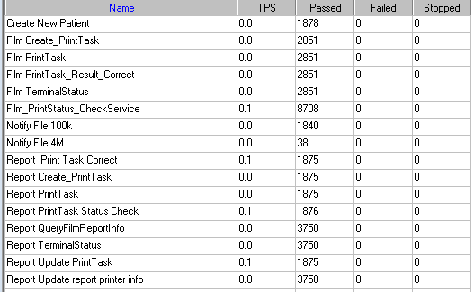

Test Statistic Report of PS
Analysis Summary | Period: 2018/8/12 9:07 - 2018/8/12 17:17

Scenario Name: | E:\ECS\Performance\Script\208\ScenarioPUMA_Reliability_171.lrs
Results in Session: | c:\Users\Administrator\AppData\Local\Temp\res119\res119.lrr
Duration: | 8 hours, 9 minutes and 27 seconds.

Statistics Summary

Maximum Running Vusers: |  | 16
Total Throughput (bytes): |  | 16,706,770
Average Throughput (bytes/second): |  | 569
Total Hits: |  | 17,261
Average Hits per Second: |  | 0.588 | View HTTP Responses Summary
Total Errors: |  | 2

You can define SLA data using the SLA configuration wizard
You can analyze transaction behavior using the Analyze Transaction mechanism

Transaction Summary

Transactions: | Total Passed: 44,494 | Total Failed: 0 | Total Stopped: 0 | Average Response Time

Transaction Name | SLA Status | Minimum | Average | Maximum | Std. Deviation | 90 Percent | Pass | Fail | Stop
Create New Patient |  | 0.078 | 0.188 | 7.289 | 0.272 | 0.328 | 1,878 | 0 | 0
Film Create_PrintTask |  | 0.827 | 1.252 | 10.797 | 0.465 | 1.81 | 2,851 | 0 | 0
Film PrintTask |  | 0.016 | 0.097 | 1.186 | 0.123 | 0.218 | 2,851 | 0 | 0
Film PrintTask_Result_Correct |  | 0 | 0 | 0.016 | 0.001 | 0 | 2,851 | 0 | 0
Film TerminalStatus |  | 0 | 0.08 | 4.867 | 0.148 | 0.187 | 2,851 | 0 | 0
Film_PrintStatus_CheckService |  | 0 | 0.086 | 8.002 | 0.187 | 0.218 | 8,708 | 0 | 0
Notify File 100k |  | 0.031 | 0.409 | 9.064 | 0.482 | 0.863 | 1,840 | 0 | 0
Notify File 4M |  | 0.094 | 0.527 | 2.153 | 0.373 | 1.026 | 38 | 0 | 0
Report Print Task Correct |  | 0 | 0 | 0 | 0 | 0 | 1,875 | 0 | 0
Report Create_PrintTask |  | 0.406 | 0.796 | 7.414 | 0.397 | 1.232 | 1,875 | 0 | 0
Report PrintTask |  | 0.016 | 0.13 | 5.374 | 0.209 | 0.318 | 1,875 | 0 | 0
Report PrintTask Status Check |  | 0 | 0.093 | 9.032 | 0.287 | 0.212 | 1,876 | 0 | 0
Report QueryFilmReportInfo |  | 0.499 | 0.902 | 18.169 | 0.513 | 1.364 | 3,750 | 0 | 0
Report TerminalStatus |  | 0 | 0.078 | 6.412 | 0.169 | 0.196 | 3,750 | 0 | 0
Report Update PrintTask |  | 0.016 | 0.159 | 11.99 | 0.345 | 0.359 | 1,875 | 0 | 0
Report Update report printer info |  | 0 | 0.074 | 9.108 | 0.204 | 0.187 | 3,750 | 0 | 0

Service Level Agreement Legend: |  | Pass |  | Fail |  | No Data

HTTP Responses Summary

HTTP Responses | Total | Per second
HTTP_200 | 17,261 | 0.588

Follow the summary report, we can see all the transactions have passed and transaction response time can accept.

Transaction summary result of PS
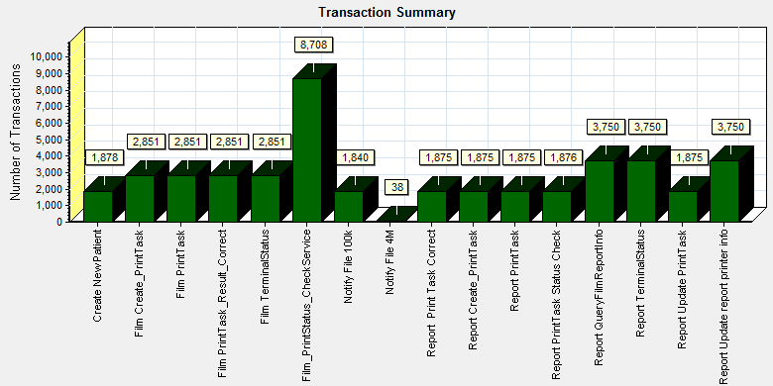
Color | Scale | Measurement
 | 1 | Pass

We can see that there is no transaction failed during the testing works.

Transaction response time result of PS
We can get the transaction response time information from the figure as follow:
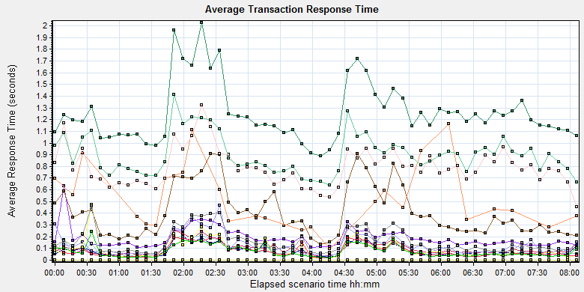

Color | Scale | Measurement | Graph's Minimum | Graph's Average | Graph's Maximum | Graph's Median
 | 1 | Create New Patient | 0.108 | 0.187 | 0.63 | 0.158
 | 1 | Film Create_PrintTask | 0.888 | 1.253 | 2.026 | 1.194
 | 1 | Film PrintTask | 0.031 | 0.099 | 0.253 | 0.077
 | 1 | Film PrintTask_Result_Correct | 0 | 0 | 0.001 | 0
 | 1 | Film TerminalStatus | 0.022 | 0.081 | 0.206 | 0.064
 | 1 | Film_PrintStatus_CheckService | 0.019 | 0.083 | 0.209 | 0.058
 | 1 | Notify File 100k | 0.137 | 0.407 | 0.911 | 0.358
 | 1 | Notify File 4M | 0.094 | 0.519 | 1.162 | 0.432
 | 1 | Report Print Task Correct | 0 | 0 | 0 | 0
 | 1 | Report Create_PrintTask | 0.456 | 0.793 | 1.326 | 0.773
 | 1 | Report PrintTask | 0.033 | 0.131 | 0.468 | 0.103
 | 1 | Report PrintTask Status Check | 0.021 | 0.093 | 0.474 | 0.063
 | 1 | Report QueryFilmReportInfo | 0.638 | 0.9 | 1.414 | 0.873
 | 1 | Report TerminalStatus | 0.017 | 0.078 | 0.193 | 0.056
 | 1 | Report Update PrintTask | 0.055 | 0.159 | 0.459 | 0.116
 | 1 | Report Update report printer info | 0.018 | 0.075 | 0.24 | 0.054

Transaction response time

This figure information shows all transaction response time. We can analysis that there are no transaction response time more than 3 seconds. It`s good performance for our system.

Test result of Web service

Test result of web transactions
After the performance testing works, the transactions result of we module as follow:
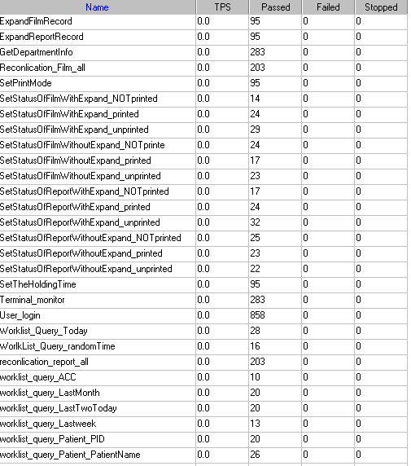
Follow the figure, we can see that there are no transactions failed.

Test Statistic Report of Web
Analysis Summary | Period: 12/08/2018 09:33:23 - 12/08/2018 15:37:40

Scenario Name: | D:\Performance\ScenarioPUMA_Reliability_171.lrs
Results in Session: | c:\Users\administrator\appdata\local\temp\res1190\res1190.lrr
Duration: | 6 hours, 4 minutes and 17 seconds.

Statistics Summary

Maximum Running Vusers: |  |  |  | 5
Total Throughput (bytes): |  |  | 226,980,963
Average Throughput (bytes/second): |  |  |  | 10,384
Total Hits: |  |  |  | 20,836
Average Hits per Second: |  |  |  | 0.953
 | Transaction Summary

Transactions: | Total Passed: 2,637 | Total Failed: 0 | Total Stopped: 0 | Average Response Time

 | Pass | Fail | Stop
Total | 2,637 | 0 | 0

Transaction Name | Minimum | Average | Maximum | Std. Deviation | 90 Percent | Pass | Fail | Stop
ExpandFilmRecord | 0.039 | 1.636 | 9.702 | 2.061 | 4.59 | 95 | 0 | 0
ExpandReportRecord | 0.006 | 0.017 | 0.194 | 0.027 | 0.027 | 95 | 0 | 0
GetDepartmentInfo | 0.005 | 0.015 | 0.35 | 0.032 | 0.018 | 283 | 0 | 0
Reconlication_Film_all | 0.162 | 0.488 | 4.097 | 0.755 | 0.833 | 203 | 0 | 0
reconlication_report_all | 0.026 | 0.208 | 3.47 | 0.553 | 0.295 | 203 | 0 | 0
SetPrintMode | 0.026 | 0.931 | 3.892 | 1.344 | 3.338 | 95 | 0 | 0
SetStatusOfFilmWithExpand_NOTprinted | 0.08 | 2.396 | 7.782 | 2.219 | 5.492 | 14 | 0 | 0
SetStatusOfFilmWithExpand_printed | 0.1 | 2.833 | 8.503 | 2.932 | 7.124 | 24 | 0 | 0
SetStatusOfFilmWithExpand_unprinted | 0.082 | 3.186 | 13.433 | 2.968 | 5.791 | 29 | 0 | 0
SetStatusOfFilmWithoutExpand_NOTprinte | 0.04 | 0.662 | 3.324 | 1.024 | 3.193 | 24 | 0 | 0
SetStatusOfFilmWithoutExpand_printed | 0.045 | 1.22 | 5.011 | 1.606 | 3.369 | 17 | 0 | 0
SetStatusOfFilmWithoutExpand_unprinted | 0.052 | 0.906 | 3.501 | 1.275 | 3.244 | 23 | 0 | 0
SetStatusOfReportWithExpand_NOTprinted | 0.041 | 0.989 | 4.447 | 1.494 | 3.54 | 17 | 0 | 0
SetStatusOfReportWithExpand_printed | 0.038 | 0.931 | 3.613 | 1.388 | 3.214 | 24 | 0 | 0
SetStatusOfReportWithExpand_unprinted | 0.039 | 0.769 | 3.68 | 1.299 | 3.284 | 32 | 0 | 0
SetStatusOfReportWithoutExpand_NOTprinted | 0.049 | 1.372 | 4.112 | 1.564 | 3.572 | 25 | 0 | 0
SetStatusOfReportWithoutExpand_printed | 0.04 | 1.212 | 4.621 | 1.522 | 3.372 | 23 | 0 | 0
SetStatusOfReportWithoutExpand_unprinted | 0.048 | 1.059 | 3.992 | 1.484 | 3.373 | 22 | 0 | 0
SetTheHoldingTime | 0.023 | 1.033 | 3.762 | 1.478 | 3.353 | 95 | 0 | 0
Terminal_monitor | 0.097 | 0.242 | 2.258 | 0.286 | 0.479 | 283 | 0 | 0
User_login | 0.169 | 0.498 | 4.516 | 0.494 | 1.063 | 858 | 0 | 0
worklist_query_ACC | 0.011 | 0.023 | 0.063 | 0.016 | 0.037 | 10 | 0 | 0
worklist_query_LastMonth | 0.037 | 0.089 | 0.259 | 0.063 | 0.212 | 20 | 0 | 0
worklist_query_LastTwoToday | 0.013 | 0.061 | 0.218 | 0.057 | 0.128 | 20 | 0 | 0
worklist_query_Lastweek | 0.04 | 0.099 | 0.513 | 0.127 | 0.208 | 13 | 0 | 0
worklist_query_Patient_PatientName | 0.014 | 0.037 | 0.11 | 0.028 | 0.084 | 26 | 0 | 0
worklist_query_Patient_PID | 0.014 | 0.057 | 0.396 | 0.09 | 0.091 | 20 | 0 | 0
Worklist_Query_Today | 0.02 | 0.174 | 3.171 | 0.582 | 0.23 | 28 | 0 | 0
WorlkList_Query_randomTime | 0.033 | 0.07 | 0.283 | 0.057 | 0.093 | 16 | 0 | 0

Service Level Agreement Legend: |  | Pass |  | Fail |  | No Data

HTTP Responses Summary

HTTP Responses | Total | Per second
HTTP_200 | 19,978 | 0.914
HTTP_302 | 858 | 0.039
Follow the summary report, we can see all the transactions have passed and transaction response time can accept.

Transaction summary result of Web
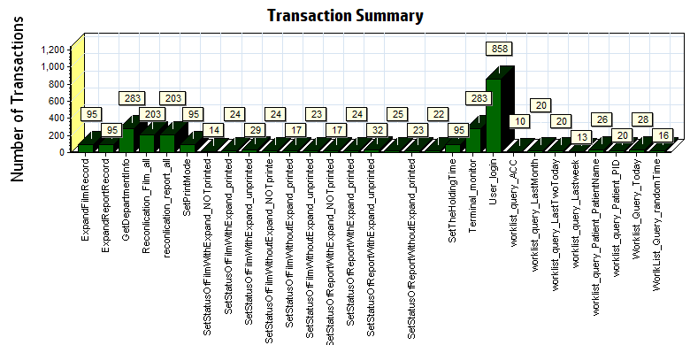
Color | Scale | Measurement
 | 1 | Pass

We can see that there is no transaction failed during the testing works.

Transaction response time result of Web
We can get the transaction response time information from the figure as follow:
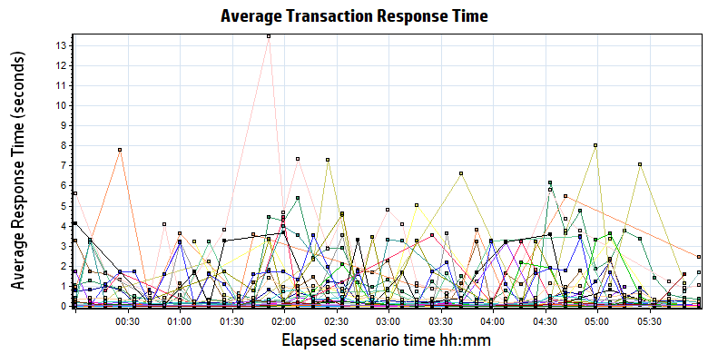
Color | Scale | Measurement | Minimum | Average | Maximum
 | 1 | ExpandFilmRecord | 0.039 | 1.636 | 9.702
 | 1 | ExpandReportRecord | 0.006 | 0.017 | 0.194
 | 1 | GetDepartmentInfo | 0.005 | 0.015 | 0.350
 | 1 | Reconlication_Film_all | 0.162 | 0.488 | 4.097
 | 1 | reconlication_report_all | 0.026 | 0.208 | 3.470
 | 1 | SetPrintMode | 0.026 | 0.931 | 3.892
 | 1 | SetStatusOfFilmWithExpand_NOTprinted | 0.080 | 2.396 | 7.782
 | 1 | SetStatusOfFilmWithExpand_printed | 0.100 | 2.833 | 8.503
 | 1 | SetStatusOfFilmWithExpand_unprinted | 0.082 | 3.186 | 13.433
 | 1 | SetStatusOfFilmWithoutExpand_NOTprinte | 0.040 | 0.662 | 3.324
 | 1 | SetStatusOfFilmWithoutExpand_printed | 0.045 | 1.220 | 5.011
 | 1 | SetStatusOfFilmWithoutExpand_unprinted | 0.052 | 0.906 | 3.501
 | 1 | SetStatusOfReportWithExpand_NOTprinted | 0.041 | 0.989 | 4.447
 | 1 | SetStatusOfReportWithExpand_printed | 0.038 | 0.931 | 3.613
 | 1 | SetStatusOfReportWithExpand_unprinted | 0.039 | 0.769 | 3.680
 | 1 | SetStatusOfReportWithoutExpand_NOTprinted | 0.049 | 1.372 | 4.112
 | 1 | SetStatusOfReportWithoutExpand_printed | 0.040 | 1.212 | 4.621
 | 1 | SetStatusOfReportWithoutExpand_unprinted | 0.048 | 1.059 | 3.992
 | 1 | SetTheHoldingTime | 0.023 | 1.033 | 3.762
 | 1 | Terminal_monitor | 0.097 | 0.242 | 2.258
 | 1 | User_login | 0.169 | 0.498 | 4.516
 | 1 | worklist_query_ACC | 0.011 | 0.023 | 0.063
 | 1 | worklist_query_LastMonth | 0.037 | 0.089 | 0.259
 | 1 | worklist_query_LastTwoToday | 0.013 | 0.061 | 0.218
 | 1 | worklist_query_Lastweek | 0.040 | 0.099 | 0.513
 | 1 | worklist_query_Patient_PatientName | 0.014 | 0.037 | 0.110
 | 1 | worklist_query_Patient_PID | 0.014 | 0.057 | 0.396
 | 1 | Worklist_Query_Today | 0.020 | 0.174 | 3.171
 | 1 | WorlkList_Query_randomTime | 0.033 | 0.070 | 0.283
Transaction response time

Follow the figure: we can see that the transaction average response time is less than 4 seconds. But some transactions response time is not smoothly. We should monitor that and try to fix the issues.

Performance bottleneck analysis

Hardware usage analysis
During the testing work, we use the test tool to monitor the server hardware usage include the CPU, Memory, hard disk and etc.
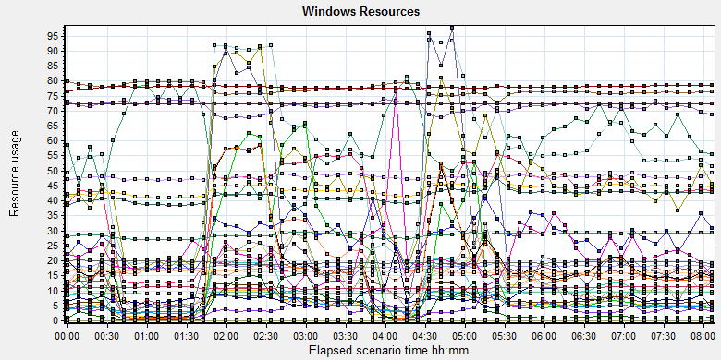
Color | Scale | Measurement | Minimum | Average | Maximum | Std. Deviation
 | 0.1 | % Disk Time (PhysicalDisk _Total):10.184.129.108 | 1.943 | 144.704 | 13112.083 | 271.074
 | 1 | % Idle Time (PhysicalDisk _Total):10.184.129.108 | 0 | 59.179 | 98.59 | 23.017
 | 100 | % Interrupt Time (Processor _Total):10.184.129.108 | 0 | 0.143 | 1.128 | 0.134
 | 1 | % Privileged Time (Processor _Total):10.184.129.108 | 0 | 5.556 | 17.444 | 3.418
 | 10 | % Processor Time (Process CloudDataUploadService):10.184.129.108 | 0 | 0.752 | 14.508 | 1.384
 | 1 | % Processor Time (Processor _Total):10.184.129.108 | 0.781 | 55.217 | 100 | 26.888
 | 0.01 | Available MBytes (Memory):10.184.129.108 | 6973 | 7704.322 | 8213 | 172.525
 | 0.0001 | Avg. Disk Bytes/Transfer (PhysicalDisk _Total):10.184.129.108 | 972.8 | 179682.53 | 1249028.655 | 157075.381
 | 10 | Avg. Disk Queue Length (PhysicalDisk _Total):10.184.129.108 | 0.019 | 1.447 | 131.121 | 2.711
 | 10 | Avg. Disk Write Queue Length (PhysicalDisk _Total):10.184.129.108 | 0.019 | 1.252 | 22.579 | 1.338
 | 0.001 | Bytes Total/sec (Server):10.184.129.108 | 14471.872 | 18151.065 | 260978.525 | 2498.784
 | 1E-07 | Cache Bytes (Memory):10.184.129.108 | 269893632 | 286209815.961 | 308727808 | 8582073.467
 | 1E-09 | Committed Bytes (Memory):10.184.129.108 | 8835493888 | 9398247526.568 | 10406977536 | 217787863.82
 | 0.001 | Context Switches/sec (System):10.184.129.108 | 2642.54 | 40765.966 | 108561.299 | 22466.931
 | 10 | Current Disk Queue Length (PhysicalDisk _Total):10.184.129.108 | 0 | 1.426 | 132 | 3.626
 | 1E-05 | Disk Read Bytes/sec (PhysicalDisk _Total):10.184.129.108 | 0 | 1799025.922 | 71561318.841 | 3207552.076
 | 1 | Disk Reads/sec (PhysicalDisk _Total):10.184.129.108 | 0 | 19.102 | 707.705 | 27.274
 | 1 | Disk Transfers/sec (PhysicalDisk _Total):10.184.129.108 | 2.325 | 46.907 | 725.639 | 33.724
 | 1E-06 | Disk Write Bytes/sec (PhysicalDisk _Total):10.184.129.108 | 2551.376 | 5571317.968 | 31155380.416 | 4575272.12
 | 1 | Disk Writes/sec (PhysicalDisk _Total):10.184.129.108 | 1.329 | 27.805 | 253.988 | 15.736
 | 0.001 | File Data Operations/sec (System):10.184.129.108 | 273.011 | 9351.431 | 33335.757 | 7679.698
 | 1E-05 | Free Megabytes (LogicalDisk _Total):10.184.129.108 | 1586554 | 1626565.694 | 1665603 | 23994.447
 | 0.001 | Interrupts/sec (Processor _Total):10.184.129.108 | 540.718 | 5630.306 | 31290.07 | 4445.903
 | 0.0001 | Page Faults/sec (Memory):10.184.129.108 | 73.071 | 62247.542 | 196282.521 | 45635.606
 | 0.1 | Page Faults/sec (Process CloudDataUploadService):10.184.129.108 | 0 | 223.618 | 6395.67 | 485.312
 | 1E-06 | Page File Bytes (Process CloudDataUploadService):10.184.129.108 | 42242048 | 47898709.754 | 83550208 | 1904724.8
 | 1 | Page Reads/sec (Memory):10.184.129.108 | 0 | 18.315 | 723.978 | 27.247
 | 0.01 | Pages/sec (Memory):10.184.129.108 | 0 | 416.062 | 5295.336 | 690.214
 | 1E-06 | Pool Nonpaged Bytes (Memory):10.184.129.108 | 75587584 | 77938021.307 | 80072704 | 488807.469
 | 0.0001 | Pool Nonpaged Bytes (Server):10.184.129.108 | 630463 | 714018.259 | 790207 | 24692.478
 | 1E-07 | Pool Paged Bytes (Memory):10.184.129.108 | 187564032 | 194669019.429 | 203177984 | 3612893.68
 | 0.001 | Pool Paged Bytes (Server):10.184.129.108 | 72245 | 72245 | 72245 | 0
 | 1 | Pool Paged Failures (Server):10.184.129.108 | 0 | 0 | 0 | 0
 | 1E-08 | Private Bytes (Process _Total):10.184.129.108 | 3653181440 | 4158895589.097 | 5109260288 | 192712363.521
 | 10 | Processor Queue Length (System):10.184.129.108 | 0 | 2.728 | 51 | 5.205
 | 1 | Split IO/Sec (PhysicalDisk _Total):10.184.129.108 | 0 | 3.776 | 220.744 | 8.469
 | 1E-07 | System Cache Resident Bytes (Memory):10.184.129.108 | 269893632 | 286210413.714 | 308727808 | 8582120.015
 | 0.001 | Threads (Objects):10.184.129.108 | 10441 | 11017.358 | 11623 | 283.241
 | 1E-08 | Working Set (Process _Total):10.184.129.108 | 3924684800 | 4395821813.071 | 5384916992 | 193010110.831

Description: Displays a summary of the System Resources usage for each Windows based host.

Follow this information we can get that:
The CPU resource has the bottleneck. The average process time is 55%, but if the system has the upload task, the usage will grow up and value is more than 80%.
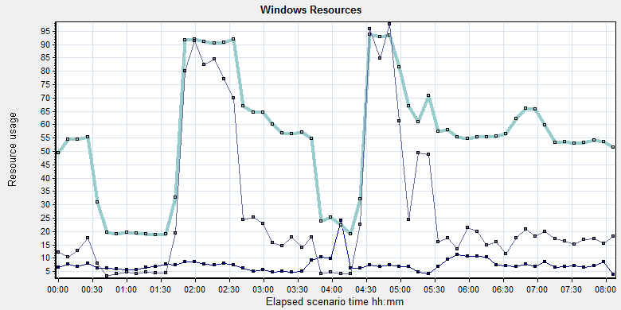
Color | Scale | Measurement | Minimum | Average | Maximum
 | 10 | % Processor Time (Process CloudDataUploadService):10.184.129.108 | 0 | 0.752 | 14.508
 | 1 | % Processor Time (Processor _Total):10.184.129.108 | 0.781 | 55.217 | 100
 | 10 | Processor Queue Length (System):10.184.129.108 | 0 | 2.728 | 51
If the system exist a lot image need to upload, the system processor usage time will more than 80% and queue length will be 8-9. The CPU processor queue is less than the threshold value 12 (6*2). But the process time is more than the threshold 80%. The CPU resource will used to zip the DICOM files and upload operations.

The memory resource do not has the bottleneck. There is enough resource for system to use.
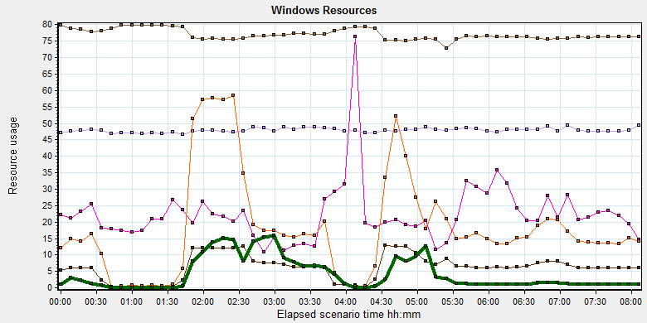
Color | Scale | Measurement | Minimum | Average | Maximum | Std. Deviation
 | 0.01 | Available MBytes (Memory):10.184.129.108 | 6973 | 7704.322 | 8213 | 172.525
 | 0.0001 | Page Faults/sec (Memory):10.184.129.108 | 73.071 | 62247.542 | 196282.521 | 45635.606
 | 0.1 | Page Faults/sec (Process CloudDataUploadService):10.184.129.108 | 0 | 223.618 | 6395.67 | 485.312
 | 1E-06 | Page File Bytes (Process CloudDataUploadService):10.184.129.108 | 42242048 | 47898709.754 | 83550208 | 1904724.8
 | 1 | Page Reads/sec (Memory):10.184.129.108 | 0 | 18.315 | 723.978 | 27.247
 | 0.01 | Pages/sec (Memory):10.184.129.108 | 0 | 416.062 | 5295.336 | 690.214

The disk has stress during performance testing works:
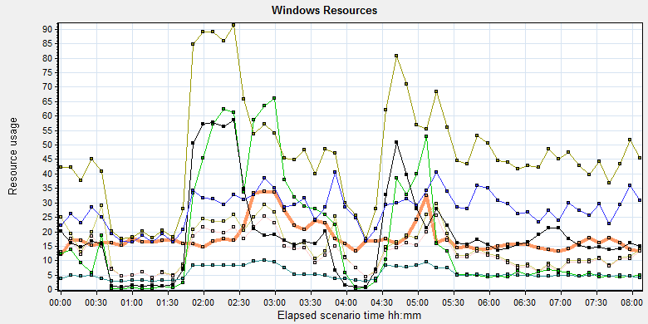
Color | Scale | Measurement | Minimum | Average | Maximum | Std. Deviation
 | 0.0001 | Avg. Disk Bytes/Transfer (PhysicalDisk _Total):10.184.129.108 | 972.8 | 179682.53 | 1249028.655 | 157075.381
 | 10 | Avg. Disk Queue Length (PhysicalDisk _Total):10.184.129.108 | 0.019 | 1.447 | 131.121 | 2.711
 | 10 | Avg. Disk Write Queue Length (PhysicalDisk _Total):10.184.129.108 | 0.019 | 1.252 | 22.579 | 1.338
 | 1E-05 | Disk Read Bytes/sec (PhysicalDisk _Total):10.184.129.108 | 0 | 1799025.922 | 71561318.841 | 3207552.076
 | 1 | Disk Reads/sec (PhysicalDisk _Total):10.184.129.108 | 0 | 19.102 | 707.705 | 27.274
 | 1 | Disk Transfers/sec (PhysicalDisk _Total):10.184.129.108 | 2.325 | 46.907 | 725.639 | 33.724
 | 1E-06 | Disk Write Bytes/sec (PhysicalDisk _Total):10.184.129.108 | 2551.376 | 5571317.968 | 31155380.416 | 4575272.12
 | 1 | Disk Writes/sec (PhysicalDisk _Total):10.184.129.108 | 1.329 | 27.805 | 253.988 | 15.736

Follow the figure: we can see that there are many disk tasks exist in the system during the testing work. The thought for disk is accepted, the stress is too many queue need to process for disk.

SQL Server resource usage analysis
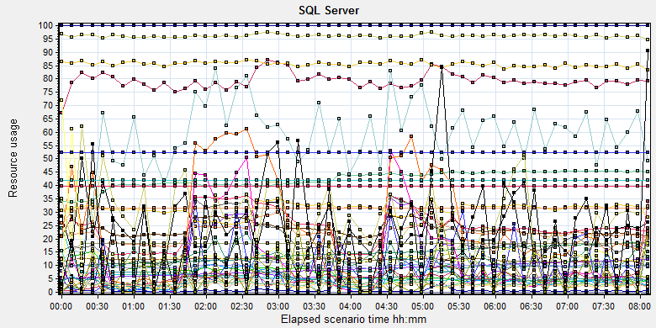
Color | Scale | Measurement | Minimum | Average | Maximum
 | 1 | Average Latch Wait Time (ms) (MSSQL$GCPACSWS|Latches):10.184.129.108 | 0.071 | 9.822 | 339.12
 | 1 | Buffer cache hit ratio (MSSQL$GCPACSWS|Buffer Manager):10.184.129.108 | 74.508 | 99.997 | 100
 | 1 | Cache Hit Ratio (MSSQL$GCPACSWS|Catalog Metadata _Total):10.184.129.108 | 9.704 | 14.292 | 18.79
 | 1 | Cache Hit Ratio (MSSQL$GCPACSWS|Cursor Manager by Type _Total):10.184.129.108 | 52.86 | 79.243 | 91.066
 | 1 | Cache Hit Ratio (MSSQL$GCPACSWS|Plan Cache _Total):10.184.129.108 | 70.129 | 85.558 | 95.93
 | 1 | Checkpoint pages/sec (MSSQL$GCPACSWS|Buffer Manager):10.184.129.108 | 0 | 3.368 | 109.989
 | 0.01 | Connection Memory (KB) (MSSQL$GCPACSWS|Memory Manager):10.184.129.108 | 1392 | 2377.505 | 3152
 | 0.1 | Connection Reset/sec (MSSQL$GCPACSWS|General Statistics):10.184.129.108 | 27.567 | 121.785 | 295.213
 | 1 | CPU usage % (MSSQL$GCPACSWS|Resource Pool Stats default):10.184.129.108 | 0.232 | 22.033 | 95.046
 | 1 | CPU usage target % (MSSQL$GCPACSWS|Resource Pool Stats default):10.184.129.108 | 44 | 96.139 | 99
 | 1 | Current latch waits (MSOLAP$GCPACSWS|Locks):10.184.129.108 | 0 | 0 | 0
 | 1 | Cursor flushes (MSSQL$GCPACSWS|Cursor Manager Total):10.184.129.108 | 0 | 0 | 0
 | 0.0001 | Cursor memory usage (MSSQL$GCPACSWS|Cursor Manager by Type _Total):10.184.129.108 | 88 | 41979.349 | 742576
 | 0.0001 | Database pages (MSSQL$GCPACSWS|Buffer Manager):10.184.129.108 | 334059 | 422797.795 | 457491
 | 10 | Errors/sec (MSSQL$GCPACSWS|SQL Errors _Total):10.184.129.108 | 0 | 2.45 | 32.57
 | 1 | Free list stalls/sec (MSSQL$GCPACSWS|Buffer Manager):10.184.129.108 | 0 | 0 | 0
 | 0.0001 | Free pages (MSSQL$GCPACSWS|Buffer Manager):10.184.129.108 | 22455 | 67404.094 | 182596
 | 0.001 | Granted Workspace Memory (KB) (MSSQL$GCPACSWS|Memory Manager):10.184.129.108 | 0 | 22433.926 | 757000
 | 1000 | Latch waits/sec (MSOLAP$GCPACSWS|Locks):10.184.129.108 | 0 | 0.005 | 0.358
 | 0.01 | Latch Waits/sec (MSSQL$GCPACSWS|Latches):10.184.129.108 | 0 | 895.222 | 3210.907
 | 100 | Lazy writes/sec (MSSQL$GCPACSWS|Buffer Manager):10.184.129.108 | 0 | 0.094 | 5.647
 | 0.001 | Lock Memory (KB) (MSSQL$GCPACSWS|Memory Manager):10.184.129.108 | 3928 | 5868.252 | 23928
 | 1 | Lock Timeouts (timeout > 0)/sec (MSSQL$GCPACSWS|Locks _Total):10.184.129.108 | 0 | 0 | 0
 | 10 | Lock Timeouts/sec (MSSQL$GCPACSWS|Locks _Total):10.184.129.108 | 0 | 0.474 | 13.617
 | 0.1 | Lock Wait Time (ms) (MSSQL$GCPACSWS|Locks _Total):10.184.129.108 | 0 | 118.467 | 14332.015
 | 1 | Lock waits/sec (MSOLAP$GCPACSWS|Locks):10.184.129.108 | 0 | 0 | 0
 | 100 | Lock Waits/sec (MSSQL$GCPACSWS|Locks _Total):10.184.129.108 | 0 | 0.259 | 16.274
 | 1E-05 | Max memory (KB) (MSSQL$GCPACSWS|Resource Pool Stats default):10.184.129.108 | 3984568 | 3984568 | 3984568
 | 1E-05 | Maximum Workspace Memory (KB) (MSSQL$GCPACSWS|Memory Manager):10.184.129.108 | 2481480 | 3139575.739 | 3151800
 | 1 | Memory grant timeouts/sec (MSSQL$GCPACSWS|Resource Pool Stats default):10.184.129.108 | 0 | 0 | 0
 | 10 | Memory Grants Outstanding (MSSQL$GCPACSWS|Memory Manager):10.184.129.108 | 0 | 1.952 | 8
 | 1 | Memory Grants Pending (MSSQL$GCPACSWS|Memory Manager):10.184.129.108 | 0 | 0 | 0
 | 1E-18 | Number of active cursor plans (MSSQL$GCPACSWS|Cursor Manager by Type _Total):10.184.129.108 | 725 | 1.80719025993054E+19 | 1.84467440737096E+19
 | 1 | Number of Deadlocks/sec (MSSQL$GCPACSWS|Locks _Total):10.184.129.108 | 0 | 0 | 0
 | 1 | Number of SuperLatches (MSSQL$GCPACSWS|Latches):10.184.129.108 | 0 | 0 | 0
 | 0.001 | Optimizer Memory (KB) (MSSQL$GCPACSWS|Memory Manager):10.184.129.108 | 5008 | 8638.26 | 15632
 | 1 | Page Deallocations/sec (MSSQL$GCPACSWS|Access Methods):10.184.129.108 | 0 | 11.98 | 410.726
 | 0.001 | Page life expectancy (MSSQL$GCPACSWS|Buffer Manager):10.184.129.108 | 196 | 5322.994 | 86904
 | 0.0001 | Page lookups/sec (MSSQL$GCPACSWS|Buffer Manager):10.184.129.108 | 0 | 311309.724 | 677770.149
 | 0.1 | Page reads/sec (MSSQL$GCPACSWS|Buffer Manager):10.184.129.108 | 0 | 11.685 | 24852.543
 | 10 | Page Splits/sec (MSSQL$GCPACSWS|Access Methods):10.184.129.108 | 0 | 5.792 | 65.425
 | 1 | Page writes/sec (MSSQL$GCPACSWS|Buffer Manager):10.184.129.108 | 0 | 5.436 | 185.979
 | 1E-05 | Query exec memory target (KB) (MSSQL$GCPACSWS|Resource Pool Stats default):10.184.129.108 | 2483400 | 3139736.453 | 3151800
 | 0.01 | Reserved pages (MSSQL$GCPACSWS|Buffer Manager):10.184.129.108 | 0 | 2741.471 | 94577
 | 0.001 | SQL Cache Memory (KB) (MSSQL$GCPACSWS|Memory Manager):10.184.129.108 | 1912 | 3650.066 | 13600
 | 0.1 | SQL Compilations/sec (MSSQL$GCPACSWS|SQL Statistics):10.184.129.108 | 29.228 | 99.516 | 266.805
 | 100 | SQL Re-Compilations/sec (MSSQL$GCPACSWS|SQL Statistics):10.184.129.108 | 0 | 0.139 | 87.35
 | 0.0001 | Stolen pages (MSSQL$GCPACSWS|Buffer Manager):10.184.129.108 | 3544 | 34084.111 | 167035
 | 1E-05 | Target memory (KB) (MSSQL$GCPACSWS|Resource Pool Stats default):10.184.129.108 | 3984568 | 3984568 | 3984568
 | 0.0001 | Target pages (MSSQL$GCPACSWS|Buffer Manager):10.184.129.108 | 524286 | 524286 | 524286
 | 1E-05 | Target Server Memory (KB) (MSSQL$GCPACSWS|Memory Manager):10.184.129.108 | 4194288 | 4194288 | 4194288
 | 100 | Temp Tables Creation Rate (MSSQL$GCPACSWS|General Statistics):10.184.129.108 | 0 | 0.209 | 12.29
 | 10 | Temp Tables For Destruction (MSSQL$GCPACSWS|General Statistics):10.184.129.108 | 0 | 0.582 | 43
 | 0.001 | Total Latch Wait Time (ms) (MSSQL$GCPACSWS|Latches):10.184.129.108 | 30.882 | 5819.228 | 188735.349
 | 0.0001 | Total pages (MSSQL$GCPACSWS|Buffer Manager):10.184.129.108 | 524286 | 524286 | 524286
 | 1E-05 | Total Server Memory (KB) (MSSQL$GCPACSWS|Memory Manager):10.184.129.108 | 4194288 | 4194288 | 4194288
 | 1E-05 | Used memory (KB) (MSSQL$GCPACSWS|Resource Pool Stats default):10.184.129.108 | 15720 | 278447.202 | 2023712

Database result
Follow the SQL server monitor resource, we can find the Database has some issues:

There are some latches and locks exist in the database:
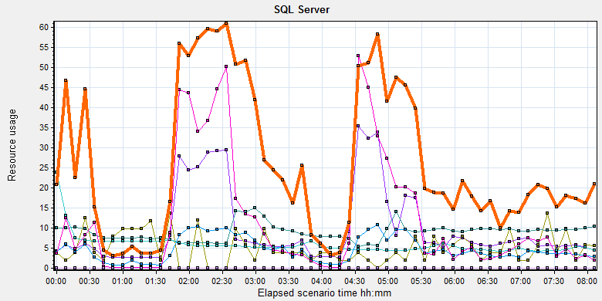
Color | Scale | Measurement | Minimum | Average | Maximum | Std. Deviation
 | 1 | Average Latch Wait Time (ms) (MSSQL$GCPACSWS|Latches):10.184.129.108 | 0.071 | 9.822 | 339.12 | 15.78
 | 1000 | Latch waits/sec (MSOLAP$GCPACSWS|Locks):10.184.129.108 | 0 | 0.005 | 0.358 | 0.04
 | 0.01 | Latch Waits/sec (MSSQL$GCPACSWS|Latches):10.184.129.108 | 0 | 895.222 | 3210.907 | 449.088
 | 0.001 | Lock Memory (KB) (MSSQL$GCPACSWS|Memory Manager):10.184.129.108 | 3928 | 5868.252 | 23928 | 2944.787
 | 1 | Lock Timeouts (timeout > 0)/sec (MSSQL$GCPACSWS|Locks _Total):10.184.129.108 | 0 | 0 | 0 | 0
 | 10 | Lock Timeouts/sec (MSSQL$GCPACSWS|Locks _Total):10.184.129.108 | 0 | 0.474 | 13.617 | 0.876
 | 0.1 | Lock Wait Time (ms) (MSSQL$GCPACSWS|Locks _Total):10.184.129.108 | 0 | 118.467 | 14332.015 | 541.824
 | 1 | Lock waits/sec (MSOLAP$GCPACSWS|Locks):10.184.129.108 | 0 | 0 | 0 | 0
 | 100 | Lock Waits/sec (MSSQL$GCPACSWS|Locks _Total):10.184.129.108 | 0 | 0.259 | 16.274 | 0.486

There are 895 latches every seconds during the testing work( Latch Waits/sec (MSSQL$GCPACSWS|Latches)). That means there are many recourse compete exist in the system. There are also has some locks and lock time out issues. Some SQL statement needs to enhance to fix these issues.
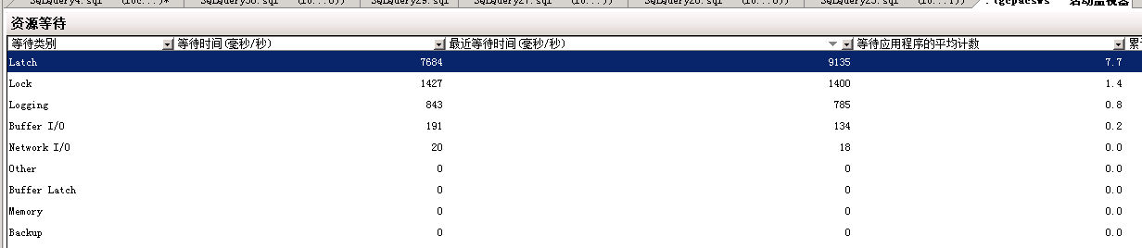
QA team guesses these issue caused by the store procedure which to synchronize upload files in wggc. The SQL statement will query the result which records need to update every 5 seconds. The SQL will full scan the main work flow table. It will lock the tables and other operations like print, change status and query will block by the SQL statement.
We captured some SQL statements which use too much system resource in testing work. There are some SQL belong to this store procedure .
We suggest develop team to resolve the issue as soon as quickly.

Test Conclusion
We executed the performance testing scenario for 8 hours. The CPU resource has the bottleneck and some SQL statement need to enhance and change design. The cloud film service does not influence the operations of PS. We will continue the testing works for B24.
I collect some SQL statements which cause much resource during the testing works. Develop team need to review and try to resolve them as possible:

Testing work （Phase 3）

Test Environment
The detailed hardware configurations of all servers are described as follow:

Computer name | CPU | Memory | HD | OS | Other | Comments
PS Server Panda upgrade | Interl(R) Xeon® CPU E5-2350 @ 1.80 * 6 | 12GB | 1TB | Windows 2008 R2 64bit | SQL server workgroup 2008 | Use the network 100Mbps
Workstation Server | Intel i3-2120 3.3GHz | 2GB | 80GB | Windows 7 SP1 64bit | QTP 11 | 6 virtual machine in server
Terminal | Intel Atom D525 1.8GHz | 4GB | 450GB | Windows Embedded Standard SP1 64bit | UTF 12.0 trail
Cloud Film Server | Interl(R) Xeon® CPU E5-2620 @ 2.40 * 6 | 64GB | 1T | Windows server2016 Standard 64 bit | Mock server from develop
Cloud film DB Server | Interl(R) Xeon® CPU E5-2620 @ 2.40 * 6 | 64GB | 1T | Windows server2016 Standard 64 bit | Mysql 5.6

Table 1 Hardware Configuration

Test scenario and strategy
Virtual User: 21 Users
Duration: 8 hour
Description: Use the test tool simulates the patient operations. Monitor the server software and hardware resource usage. The detail information as follow:
- Use automation tool simulate the doctor print film work. Simulate 6 GX Platform by using QTP and WinDPSTester tool. Each client prints one film which size is 10MB every 30 seconds.
- Use LR tool simulate 8 K2/K3 terminals to print film. Each client prints one film which size is 10MB random 5 to 30 seconds.
- Use LR tool simulate 8 users to do report archive operations. Each client archive report in random 5 to 30 seconds and size is random with 100kb and 4Mb.
- Use LR tool simulate 8 terminals to print paper reports. Each client prints report random 5 to 30 seconds.
- The OCR setting is not has rule for GX platforms in step1 and other setting are set as default. The OCR service will under the strong stress without configure the rule.
- Simulate 5 users to do the query information, view monitor page, query reconciliation films and report, expand the record, change the status, set holding time and other operations in worklist.
- Monitor the transaction response time.
- Monitor the hardware resource usage on PS.
- Monitor the resource usage for database on PS.
- Start/Stop 2 virtual users every 10 seconds and run the scenario for 8 hours.
- Simulate the Upload network bandwidth to 20M.

Note:
We will do the performance testing work under big stress for system. If system can work well under current stress and the transaction process ability meets the requirement, we will give the conclusion the system performance is pass.

Test Tool
Load Runner 12.

Database setting
Memory: Set the min and max memory size to 4GB.
Index fill factor: 80.
File: Increase the data and log files size and the rule is increase 200Mb as fixed size.

IIS setting
Connection: Set the max connection value to 4000 and keep other setting as default.

Test Object version
KIOSK cloud film 3.0.3.0 B24 + ACQ Path

Background data
We prepared a background records in the PS system. The data size is calculated by the typical site which printed 3,000 films in a workday. That means the records of films in db should more than 972,000 (3000records / day *54 weeks * 6 workday). QA team had prepared these data with SQL script and automation script. These data can backup and import by DB tool.
The detail data records in DB as follow:

Table Name | Data Volume (records)
printer.dbo.DeliveryJob | 995199
printer.dbo.ImageBox | 3530116
printer.dbo.Page | 314893
printer.dbo.Session | 571212
wggc.dbo.Patient | 1224710
wggc.dbo.Study | 1434574
wggc.dbo.AFP_PrintTerminalInfo | 70
wggc.dbo.Series | 1434524
wggc.dbo.Image | 1434527
wggc.dbo.AFP_FilmInfo | 1420905
wggc.dbo.AFP_ReportInfo | 1232003
wggc.dbo.AFP_ExamInfo | 2308723
wggc.dbo.AFP_PrintTask | 4324918
wggc.dbo.T_Integration_ExamInfo | 1421769
AFP_PrintMode | 523684
wggc.dbo.vi_KIOSK_ExamInfo_Order | 838208

Test Error
There are some errors exist in the testing work and logged as follow:
No | Description | count
1. | Error: The accession number is A201*****,Terminal1 | 16
2 | Error: Query report records to print from databse failed: the accessionnumber is A201808***** the count is 2 | 2
3 | Error: The task do not finish correct: TaskID: 43**** From Terminal: K2_1 | 5

Error analyzes:
- It caused by the service http://10.184.129.108/EHDPS/printtask/items. That means the service cannot get the report path and id to print. I will retry this service for 10 times get the result. There are two patients caused 16 failed but they still printed finally. I guess it caused by the database lock, the query operations failed.
- It caused by the test data means the patient has two reports. The test script can only process the transaction that patient has only one report. Script will output this warning and execute next iterations. They are not test error.
- For these 5 errors, the task is passed in database. Others status is 4 in database and error code are 80905007 and 80905009.
80905007: "Task Schedule Service"-"Software Error"-"Send film data to printer timeout"
80905007: "Task Schedule Service"-"Software Error"-"Task is failed because of long time unexecution"
These three issues caused by our system or the printer simulater. We should monitor them in next testing works.

Test result of PS server

Test result of PS transactions
After the performance testing works, the transactions result of PS print module as follow:
N/A Data lost by error opertations, please refer the chapter of ‘Test Statistic Report of PS’.

Test Statistic Report of PS
Analysis Summary | Period: 2018/8/16 15:10 - 2018/8/16 23:19

Scenario Name: | E:\ECS\Performance\Script\208\ScenarioPUMA_Reliability_171.lrs
Results in Session: | c:\Users\Administrator\AppData\Local\Temp\res125\res125.lrr
Duration: | 8 hours, 9 minutes and 27 seconds.

Statistics Summary

Maximum Running Vusers: |  | 16
Total Throughput (bytes): |  | 19,274,800
Average Throughput (bytes/second): |  | 656
Total Hits: |  | 19,946
Average Hits per Second: |  | 0.679 | View HTTP Responses Summary
Total Errors: |  | 23

You can define SLA data using the SLA configuration wizard
You can analyze transaction behavior using the Analyze Transaction mechanism

Transaction Summary

Transactions: | Total Passed: 53,794 | Total Failed: 16 | Total Stopped: 0 | Average Response Time

Transaction Name | SLA Status | Minimum | Average | Maximum | Std. Deviation | 90 Percent | Pass | Fail | Stop
Create New Patient |  | 0.078 | 0.153 | 1.3 | 0.075 | 0.218 | 2,347 | 0 | 0
Film Create_PrintTask |  | 0.811 | 1.201 | 12.808 | 0.392 | 1.544 | 3,350 | 0 | 0
Film PrintTask |  | 0.016 | 0.06 | 0.983 | 0.055 | 0.109 | 3,350 | 0 | 0
Film PrintTask_Result_Correct |  | 0 | 0 | 0.016 | 0 | 0 | 3,344 | 0 | 0
Film PrintTask_Result_Fail |  | 0 | 0 | 0 | 0 | 0 | 5 | 0 | 0
Film TerminalStatus |  | 0 | 0.042 | 1.108 | 0.052 | 0.078 | 3,350 | 0 | 0
Film_PrintStatus_CheckService |  | 0 | 0.04 | 0.967 | 0.048 | 0.078 | 9,897 | 0 | 0
Notify File 100k |  | 0.078 | 0.343 | 13.915 | 0.48 | 0.562 | 2,304 | 0 | 0
Notify File 4M |  | 0.159 | 0.473 | 1.092 | 0.213 | 0.764 | 43 | 0 | 0
Report Print Task Correct |  | 0 | 0 | 0 | 0 | 0 | 2,344 | 0 | 0
Report Create_PrintTask |  | 0.442 | 0.835 | 2.808 | 0.309 | 1.248 | 2,344 | 0 | 0
Report GetReportPath_fail |  | 0 | 0 | 0 | 0 | 0 | 0 | 16 | 0
Report PrintTask |  | 0.016 | 0.062 | 0.781 | 0.06 | 0.125 | 2,344 | 0 | 0
Report PrintTask Status Check |  | 0 | 0.041 | 0.624 | 0.046 | 0.08 | 2,345 | 0 | 0
Report QueryFilmReportInfo |  | 0.464 | 0.974 | 12.402 | 0.387 | 1.38 | 4,704 | 0 | 0
Report TerminalStatus |  | 0 | 0.037 | 0.827 | 0.046 | 0.078 | 4,689 | 0 | 0
Report Update PrintTask |  | 0.015 | 0.081 | 0.92 | 0.076 | 0.159 | 2,344 | 0 | 0
Report Update report printer info |  | 0 | 0.044 | 1.513 | 0.056 | 0.083 | 4,690 | 0 | 0

Service Level Agreement Legend: |  | Pass |  | Fail |  | No Data

HTTP Responses Summary

HTTP Responses | Total | Per second
HTTP_200 | 19,946 | 0.679

Follow the summary report, we can see there are 21 failed transactions during the testing work.

Transaction summary result of PS
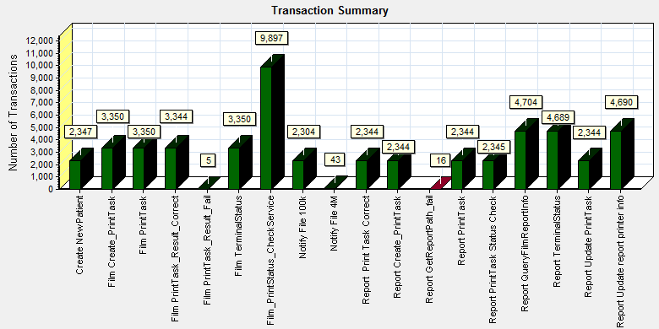
Color | Scale | Measurement
 | 1 | Pass
 | 1 | Fail

We can see that there are 21 transactions failed during the testing works.

Transaction response time result of PS
We can get the transaction response time information from the figure as follow:
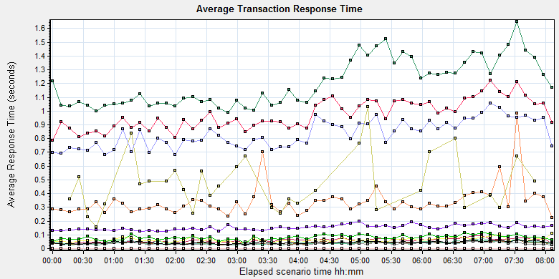
Color | Scale | Measurement | Graph's Minimum | Graph's Average | Graph's Maximum | Graph's Median | Graph's Std. Deviation
 | 1 | Create New Patient | 0.124 | 0.153 | 0.197 | 0.153 | 0.019
 | 1 | Film Create_PrintTask | 0.99 | 1.203 | 1.649 | 1.153 | 0.168
 | 1 | Film PrintTask | 0.038 | 0.06 | 0.093 | 0.064 | 0.013
 | 1 | Film PrintTask_Result_Correct | 0 | 0 | 0 | 0 | 0
 | 1 | Film PrintTask_Result_Fail | 0 | 0 | 0 | 0 | 0
 | 1 | Film TerminalStatus | 0.025 | 0.042 | 0.075 | 0.04 | 0.011
 | 1 | Film_PrintStatus_CheckService | 0.026 | 0.04 | 0.065 | 0.039 | 0.008
 | 1 | Notify File 100k | 0.222 | 0.341 | 0.985 | 0.321 | 0.115
 | 1 | Notify File 4M | 0.159 | 0.473 | 1.03 | 0.425 | 0.197
 | 1 | Report Print Task Correct | 0 | 0 | 0 | 0 | 0
 | 1 | Report Create_PrintTask | 0.681 | 0.834 | 1.055 | 0.824 | 0.099
 | 1 | Report PrintTask | 0.037 | 0.063 | 0.112 | 0.06 | 0.015
 | 1 | Report PrintTask Status Check | 0.023 | 0.041 | 0.074 | 0.039 | 0.011
 | 1 | Report QueryFilmReportInfo | 0.788 | 0.973 | 1.222 | 0.945 | 0.106
 | 1 | Report TerminalStatus | 0.025 | 0.037 | 0.055 | 0.035 | 0.007
 | 1 | Report Update PrintTask | 0.039 | 0.08 | 0.116 | 0.081 | 0.017
 | 1 | Report Update report printer info | 0.03 | 0.044 | 0.065 | 0.043 | 0.009
Transaction response time

This figure information shows all transaction response time. We can analysis that there are no transaction response time more than 3 seconds. It`s good performance for our system.

Test result of Web service

Test result of web transactions
After the performance testing works, the transactions result of we module as follow:
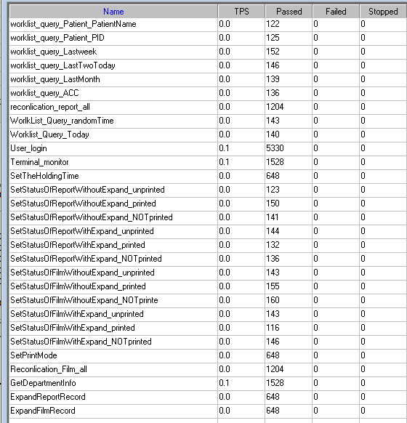
Follow the figure, we can see that there is no transactions failed.

Test Statistic Report of Web
Analysis Summary | Period: 16/08/2018 15:37:10 - 16/08/2018 23:38:37

Scenario Name: | D:\Performance\ScenarioPUMA_Reliability_171.lrs
Results in Session: | c:\Users\administrator\appdata\local\temp\res1203\res1203.lrr
Duration: | 8 hours, 1 minute and 27 seconds.

Statistics Summary

Maximum Running Vusers: | 5
Total Throughput (bytes): | 1,679,757,395
Average Throughput (bytes/second): | 58,147
Total Hits: | 140,385
Average Hits per Second: | 4.86

You can define SLA data using the SLA configuration wizard
You can analyze transaction behavior using the Analyze Transaction mechanism

Transaction Summary

Transactions: | Total Passed: 17,746 | Total Failed: 0 | Total Stopped: 0 | Average Response Time

Transaction Name | Minimum | Average | Maximum | Std. Deviation | 90 Percent | Pass | Fail | Stop
ExpandFilmRecord | 0.047 | 0.9 | 5.784 | 0.859 | 1.919 | 710 | 0 | 0
ExpandReportRecord | 0.005 | 0.01 | 0.139 | 0.011 | 0.016 | 711 | 0 | 0
GetDepartmentInfo | 0.004 | 0.009 | 0.117 | 0.009 | 0.014 | 1,674 | 0 | 0
Reconlication_Film_all | 0.141 | 0.323 | 1.689 | 0.174 | 0.546 | 1,322 | 0 | 0
reconlication_report_all | 0.019 | 0.048 | 0.472 | 0.036 | 0.084 | 1,320 | 0 | 0
SetPrintMode | 0.016 | 0.08 | 1.178 | 0.078 | 0.147 | 710 | 0 | 0
SetStatusOfFilmWithExpand_NOTprinted | 0.175 | 0.909 | 4.501 | 0.782 | 1.974 | 150 | 0 | 0
SetStatusOfFilmWithExpand_printed | 0.173 | 1.105 | 6.23 | 0.982 | 2.359 | 124 | 0 | 0
SetStatusOfFilmWithExpand_unprinted | 0.151 | 1.163 | 4.06 | 0.845 | 2.08 | 162 | 0 | 0
SetStatusOfFilmWithoutExpand_NOTprinte | 0.019 | 0.093 | 1.361 | 0.122 | 0.154 | 178 | 0 | 0
SetStatusOfFilmWithoutExpand_printed | 0.025 | 0.088 | 0.506 | 0.073 | 0.151 | 169 | 0 | 0
SetStatusOfFilmWithoutExpand_unprinted | 0.025 | 0.096 | 1.115 | 0.108 | 0.168 | 154 | 0 | 0
SetStatusOfReportWithExpand_NOTprinted | 0.025 | 0.092 | 0.644 | 0.08 | 0.154 | 145 | 0 | 0
SetStatusOfReportWithExpand_printed | 0.021 | 0.076 | 0.463 | 0.052 | 0.127 | 143 | 0 | 0
SetStatusOfReportWithExpand_unprinted | 0.023 | 0.078 | 0.376 | 0.061 | 0.144 | 160 | 0 | 0
SetStatusOfReportWithoutExpand_NOTprinted | 0.021 | 0.08 | 0.273 | 0.053 | 0.135 | 163 | 0 | 0
SetStatusOfReportWithoutExpand_printed | 0.025 | 0.079 | 0.462 | 0.056 | 0.139 | 169 | 0 | 0
SetStatusOfReportWithoutExpand_unprinted | 0.022 | 0.082 | 0.338 | 0.054 | 0.166 | 136 | 0 | 0
SetTheHoldingTime | 0.013 | 0.052 | 0.565 | 0.049 | 0.1 | 714 | 0 | 0
Terminal_monitor | 0.119 | 0.248 | 1.489 | 0.14 | 0.379 | 1,674 | 0 | 0
User_login | 0.194 | 0.421 | 2.41 | 0.201 | 0.629 | 5,845 | 0 | 0
worklist_query_ACC | 0.007 | 0.019 | 0.077 | 0.013 | 0.031 | 155 | 0 | 0
worklist_query_LastMonth | 0.017 | 0.052 | 0.248 | 0.032 | 0.09 | 151 | 0 | 0
worklist_query_LastTwoToday | 0.018 | 0.06 | 1.102 | 0.088 | 0.088 | 162 | 0 | 0
worklist_query_Lastweek | 0.018 | 0.054 | 0.181 | 0.027 | 0.09 | 165 | 0 | 0
worklist_query_Patient_PatientName | 0.007 | 0.028 | 0.506 | 0.048 | 0.039 | 133 | 0 | 0
worklist_query_Patient_PID | 0.007 | 0.029 | 0.313 | 0.043 | 0.048 | 143 | 0 | 0
Worklist_Query_Today | 0.021 | 0.082 | 2.422 | 0.198 | 0.114 | 151 | 0 | 0
WorlkList_Query_randomTime | 0.018 | 0.06 | 0.225 | 0.031 | 0.094 | 153 | 0 | 0

Service Level Agreement Legend: |  | Pass |  | Fail |  | No Data

HTTP Responses Summary

HTTP Responses | Total | Per second
HTTP_200 | 134,469 | 4.655
HTTP_302 | 5,915.6 | 0.205

Follow the summary report, we can see all the transactions had passed and transaction response time can accept.

Transaction summary result of Web
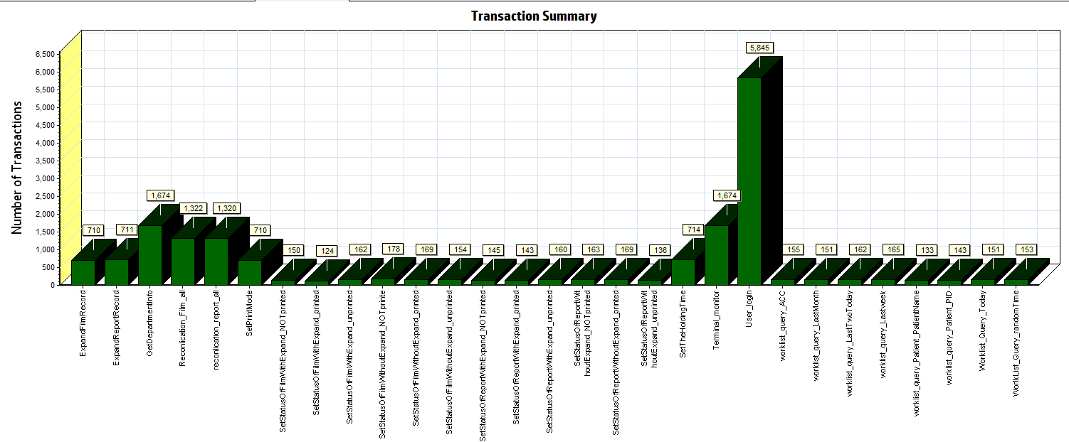
Color | Scale | Measurement
 | 1 | Pass

We can see that there is no transaction failed during the testing works.

Transaction response time result of Web
We can get the transaction response time information from the figure as follow:
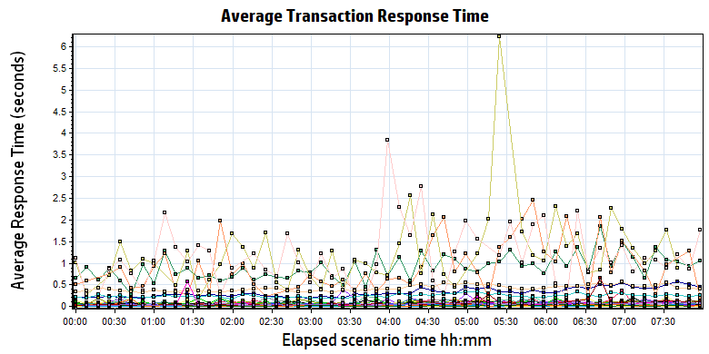
Color | Scale | Measurement | Minimum | Average | Maximum | Std. Deviation
 | 1 | ExpandFilmRecord | 0.047 | 0.900 | 5.784 | 0.859
 | 1 | ExpandReportRecord | 0.005 | 0.010 | 0.139 | 0.011
 | 1 | GetDepartmentInfo | 0.004 | 0.009 | 0.117 | 0.009
 | 1 | Reconlication_Film_all | 0.141 | 0.323 | 1.689 | 0.174
 | 1 | reconlication_report_all | 0.019 | 0.048 | 0.472 | 0.036
 | 1 | SetPrintMode | 0.016 | 0.080 | 1.178 | 0.078
 | 1 | SetStatusOfFilmWithExpand_NOTprinted | 0.175 | 0.909 | 4.501 | 0.782
 | 1 | SetStatusOfFilmWithExpand_printed | 0.173 | 1.105 | 6.230 | 0.982
 | 1 | SetStatusOfFilmWithExpand_unprinted | 0.151 | 1.163 | 4.060 | 0.845
 | 1 | SetStatusOfFilmWithoutExpand_NOTprinte | 0.019 | 0.093 | 1.361 | 0.122
 | 1 | SetStatusOfFilmWithoutExpand_printed | 0.025 | 0.088 | 0.506 | 0.073
 | 1 | SetStatusOfFilmWithoutExpand_unprinted | 0.025 | 0.096 | 1.115 | 0.108
 | 1 | SetStatusOfReportWithExpand_NOTprinted | 0.025 | 0.092 | 0.644 | 0.080
 | 1 | SetStatusOfReportWithExpand_printed | 0.021 | 0.076 | 0.463 | 0.052
 | 1 | SetStatusOfReportWithExpand_unprinted | 0.023 | 0.078 | 0.376 | 0.061
 | 1 | SetStatusOfReportWithoutExpand_NOTprinted | 0.021 | 0.080 | 0.273 | 0.053
 | 1 | SetStatusOfReportWithoutExpand_printed | 0.025 | 0.079 | 0.462 | 0.056
 | 1 | SetStatusOfReportWithoutExpand_unprinted | 0.022 | 0.082 | 0.338 | 0.054
 | 1 | SetTheHoldingTime | 0.013 | 0.052 | 0.565 | 0.049
 | 1 | Terminal_monitor | 0.119 | 0.248 | 1.489 | 0.140
 | 1 | User_login | 0.194 | 0.421 | 2.410 | 0.201
 | 1 | worklist_query_ACC | 0.007 | 0.019 | 0.077 | 0.013
 | 1 | worklist_query_LastMonth | 0.017 | 0.052 | 0.248 | 0.032
 | 1 | worklist_query_LastTwoToday | 0.018 | 0.060 | 1.102 | 0.088
 | 1 | worklist_query_Lastweek | 0.018 | 0.054 | 0.181 | 0.027
 | 1 | worklist_query_Patient_PatientName | 0.007 | 0.028 | 0.506 | 0.048
 | 1 | worklist_query_Patient_PID | 0.007 | 0.029 | 0.313 | 0.043
 | 1 | Worklist_Query_Today | 0.021 | 0.082 | 2.422 | 0.198
 | 1 | WorlkList_Query_randomTime | 0.018 | 0.060 | 0.225 | 0.031

Transaction response time
Follow the figure: we can see that the transaction average response time is less than 2 seconds. But some transactions response time is smoothly. We should monitor that and try to fix the issues.

Performance bottleneck analysis

Hardware usage analysis
During the testing work, we use the test tool to monitor the server hardware usage include the CPU, Memory, hard disk and etc.
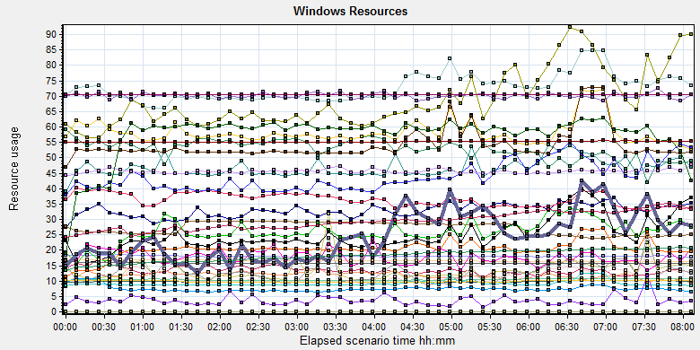
Color | Scale | Measurement | Minimum | Average | Maximum | Std. Deviation
 | 0.1 | % Disk Time (PhysicalDisk _Total):10.184.129.108 | 9.95 | 134.866 | 17542.543 | 295.448
 | 1 | % Idle Time (PhysicalDisk _Total):10.184.129.108 | 0 | 52.799 | 91.693 | 18.243
 | 100 | % Interrupt Time (Processor _Total):10.184.129.108 | 0 | 0.135 | 0.864 | 0.12
 | 10 | % Privileged Time (Processor _Total):10.184.129.108 | 0.434 | 5.825 | 20.712 | 2.32
 | 10 | % Processor Time (Process CloudDataUploadService):10.184.129.108 | 0 | 3.284 | 15.979 | 1.923
 | 1 | % Processor Time (Processor _Total):10.184.129.108 | 12.847 | 72.711 | 99.913 | 13.398
 | 0.01 | Available MBytes (Memory):10.184.129.108 | 2084 | 2717.657 | 3122 | 211.437
 | 0.0001 | Avg. Disk Bytes/Transfer (PhysicalDisk _Total):10.184.129.108 | 4191.256 | 117907.37 | 877899.776 | 97928.907
 | 10 | Avg. Disk Queue Length (PhysicalDisk _Total):10.184.129.108 | 0.099 | 1.349 | 175.425 | 2.955
 | 10 | Avg. Disk Write Queue Length (PhysicalDisk _Total):10.184.129.108 | 0.099 | 1.144 | 31.772 | 1.2
 | 0.001 | Bytes Total/sec (Server):10.184.129.108 | 17170.559 | 18044.889 | 19502.884 | 296.474
 | 1E-07 | Cache Bytes (Memory):10.184.129.108 | 125460480 | 181756193.752 | 216334336 | 19303822.948
 | 1E-09 | Committed Bytes (Memory):10.184.129.108 | 9820307456 | 10478556614.155 | 11228426240 | 219700022.087
 | 0.001 | Context Switches/sec (System):10.184.129.108 | 6361.167 | 36410.315 | 101352.389 | 17613.215
 | 10 | Current Disk Queue Length (PhysicalDisk _Total):10.184.129.108 | 0 | 1.305 | 178 | 3.074
 | 1E-05 | Disk Read Bytes/sec (PhysicalDisk _Total):10.184.129.108 | 0 | 2589403.687 | 91777911.615 | 2943277.031
 | 1 | Disk Reads/sec (PhysicalDisk _Total):10.184.129.108 | 0 | 24.842 | 664.832 | 26.54
 | 1 | Disk Transfers/sec (PhysicalDisk _Total):10.184.129.108 | 10.296 | 68.612 | 697.376 | 37.635
 | 1E-05 | Disk Write Bytes/sec (PhysicalDisk _Total):10.184.129.108 | 38089.92 | 4676333.11 | 26712560.492 | 3549849.275
 | 1 | Disk Writes/sec (PhysicalDisk _Total):10.184.129.108 | 9.299 | 43.771 | 306.443 | 22.114
 | 0.001 | File Data Operations/sec (System):10.184.129.108 | 950.599 | 9230.32 | 29066.682 | 5103.01
 | 1E-05 | Free Megabytes (LogicalDisk _Total):10.184.129.108 | 1623360 | 1657247.366 | 1690860 | 19554.304
 | 0.001 | Interrupts/sec (Processor _Total):10.184.129.108 | 1066.518 | 7464.157 | 27164.083 | 4599.51
 | 0.001 | Page Faults/sec (Memory):10.184.129.108 | 607.85 | 54211.665 | 155535.713 | 27866.804
 | 0.1 | Page Faults/sec (Process CloudDataUploadService):10.184.129.108 | 0 | 177.926 | 5507.1 | 476.902
 | 1E-06 | Page File Bytes (Process CloudDataUploadService):10.184.129.108 | 43900928 | 45583211.555 | 69660672 | 1256999.203
 | 1 | Page Reads/sec (Memory):10.184.129.108 | 0 | 20.287 | 687.414 | 21.713
 | 0.1 | Pages/sec (Memory):10.184.129.108 | 0 | 572.752 | 4295.179 | 607.413
 | 1E-06 | Pool Nonpaged Bytes (Memory):10.184.129.108 | 54763520 | 55229066.052 | 56254464 | 221972.045
 | 0.0001 | Pool Nonpaged Bytes (Server):10.184.129.108 | 631737 | 701108.223 | 783289 | 20557.685
 | 1E-07 | Pool Paged Bytes (Memory):10.184.129.108 | 156512256 | 158402140.07 | 169381888 | 1450642.628
 | 0.001 | Pool Paged Bytes (Server):10.184.129.108 | 70613 | 70613 | 70613 | 0
 | 1 | Pool Paged Failures (Server):10.184.129.108 | 0 | 0 | 0 | 0
 | 1E-09 | Private Bytes (Process _Total):10.184.129.108 | 9086722048 | 9771609726.084 | 10344050688 | 211313221.185
 | 10 | Processor Queue Length (System):10.184.129.108 | 0 | 2.455 | 41 | 3.731
 | 1 | Split IO/Sec (PhysicalDisk _Total):10.184.129.108 | 0 | 3.622 | 278.886 | 14.342
 | 1E-07 | System Cache Resident Bytes (Memory):10.184.129.108 | 125460480 | 181756575.888 | 216334336 | 19303053.573
 | 0.01 | Threads (Objects):10.184.129.108 | 2317 | 2940.474 | 3678 | 290.345
 | 1E-09 | Working Set (Process _Total):10.184.129.108 | 9504980992 | 9932552123.131 | 10626387968 | 259396038.709

Follow this information we can get that:
The CPU resource has the bottleneck. The average process time is 55%, but if the system has the upload task, the usage will grow up and value is more than 80%.
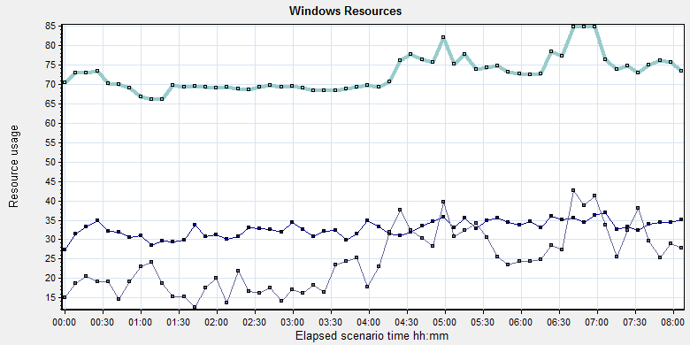
Color | Scale | Measurement | Minimum | Average | Maximum | Std. Deviation
 | 10 | % Processor Time (Process CloudDataUploadService):10.184.129.108 | 0 | 3.284 | 15.979 | 1.923
 | 1 | % Processor Time (Processor _Total):10.184.129.108 | 12.847 | 72.711 | 99.913 | 13.398
 | 10 | Processor Queue Length (System):10.184.129.108 | 0 | 2.455 | 41 | 3.731
Follow the figure we can see that the CPU is under big stress during the testing works. The CPU process time usage is between 70% and 85%. It`s close to 85% threshold value but can accept. The average CPU queue length is 2.5, it small than the threshold value (12= 6*2). The CPU has big stress but it has not bottleneck.
Compare the test scenario which do not start the cloud film services:
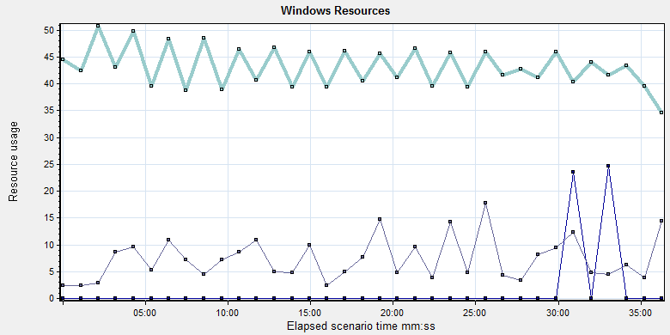
Color | Scale | Measurement | Minimum | Average | Maximum | Std. Deviation
 | 1000 | % Processor Time (Process CloudDataUploadService):10.184.129.108 | 0 | 0.001 | 0.518 | 0.027
 | 1 | % Processor Time (Processor _Total):10.184.129.108 | 5.208 | 43.245 | 85.834 | 17.252
 | 10 | Processor Queue Length (System):10.184.129.108 | 0 | 0.721 | 18 | 1.616
We can see the CPU usage is double. We should enhance the performance for our system to fix the risk.

The memory resource do not has the bottleneck. There are enough resources for system to use.
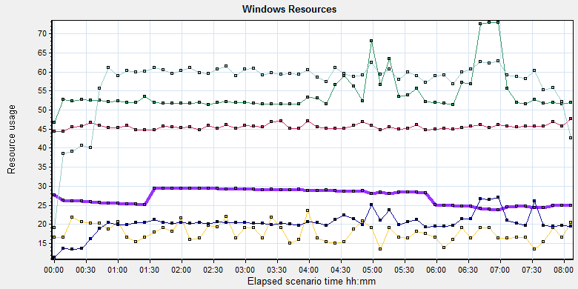
Color | Scale | Measurement | Minimum | Average | Maximum | Std. Deviation
 | 0.01 | Available MBytes (Memory):10.184.129.108 | 2084 | 2717.657 | 3122 | 211.437
 | 0.001 | Page Faults/sec (Memory):10.184.129.108 | 607.85 | 54211.665 | 155535.713 | 27866.804
 | 0.1 | Page Faults/sec (Process CloudDataUploadService):10.184.129.108 | 0 | 177.926 | 5507.1 | 476.902
 | 1E-06 | Page File Bytes (Process CloudDataUploadService):10.184.129.108 | 43900928 | 45583211.555 | 69660672 | 1256999.203
 | 1 | Page Reads/sec (Memory):10.184.129.108 | 0 | 20.287 | 687.414 | 21.713
 | 0.1 | Pages/sec (Memory):10.184.129.108 | 0 | 572.752 | 4295.179 | 607.413

The disk has stress during performance testing works:
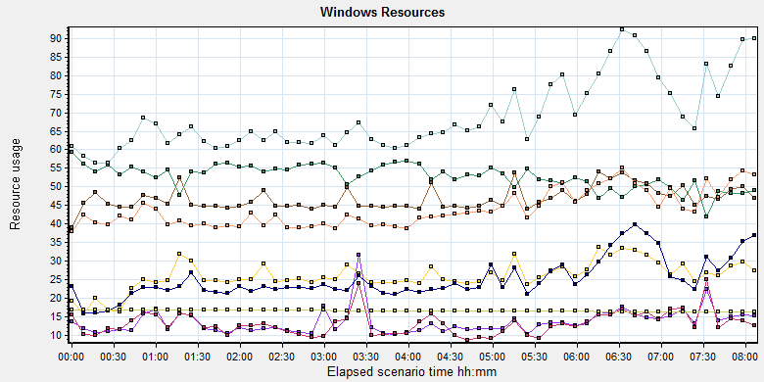
Color |  | Scale | Measurement | Minimum | Average | Maximum | Std. Deviation
 |  | 0.1 | % Disk Time (PhysicalDisk _Total):10.184.129.108 | 9.95 | 134.866 | 17542.543 | 295.448
 |  | 1 | % Idle Time (PhysicalDisk _Total):10.184.129.108 | 0 | 52.799 | 91.693 | 18.243
 |  | 10 | Current Disk Queue Length (PhysicalDisk _Total):10.184.129.108 | 0 | 1.305 | 178 | 3.074
 |  | 1E-05 | Disk Read Bytes/sec (PhysicalDisk _Total):10.184.129.108 | 0 | 2589403.687 | 91777911.615 | 2943277.031
 |  | 1 | Disk Reads/sec (PhysicalDisk _Total):10.184.129.108 | 0 | 24.842 | 664.832 | 26.54
 |  | 1 | Disk Transfers/sec (PhysicalDisk _Total):10.184.129.108 | 10.296 | 68.612 | 697.376 | 37.635
 |  | 1E-05 | Disk Write Bytes/sec (PhysicalDisk _Total):10.184.129.108 | 38089.92 | 4676333.11 | 26712560.492 | 3549849.275
 |  | 1 | Disk Writes/sec (PhysicalDisk _Total):10.184.129.108 | 9.299 | 43.771 | 306.443 | 22.114
 |  | 1E-05 | Free Megabytes (LogicalDisk _Total):10.184.129.108 | 1623360 | 1657247.366 | 1690860 | 19554.304
 | Follow the figure: we can see that there are many disk tasks exist in the system during the testing work. The average Disk read/sec is 24, writes/sec is 44, and transfers/sec is 67. The average disk transfer size is 7M/sec. The disk is busy, but the stress can accept.

SQL Server resource usage analysis
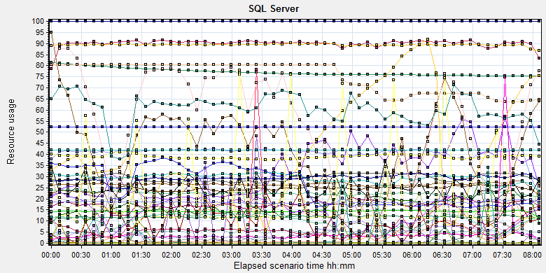
Color | Scale | Measurement | Minimum | Average | Maximum | Std. Deviation
 | 10 | Average Latch Wait Time (ms) (MSSQL$GCPACSWS|Latches):10.184.129.108 | 0.297 | 3.32 | 63.36 | 3.551
 | 1 | Buffer cache hit ratio (MSSQL$GCPACSWS|Buffer Manager):10.184.129.108 | 99.595 | 99.999 | 100 | 0.005
 | 1 | Cache Hit Ratio (MSSQL$GCPACSWS|Catalog Metadata _Total):10.184.129.108 | 75.399 | 77.12 | 81.508 | 1.646
 | 1 | Cache Hit Ratio (MSSQL$GCPACSWS|Cursor Manager by Type _Total):10.184.129.108 | 65.944 | 90.013 | 93.891 | 2.542
 | 1 | Cache Hit Ratio (MSSQL$GCPACSWS|Plan Cache _Total):10.184.129.108 | 78.953 | 89.404 | 96.891 | 3.19
 | 1 | Checkpoint pages/sec (MSSQL$GCPACSWS|Buffer Manager):10.184.129.108 | 0 | 5.942 | 1027.53 | 25.569
 | 0.01 | Connection Memory (KB) (MSSQL$GCPACSWS|Memory Manager):10.184.129.108 | 1520 | 2456.367 | 2880 | 121.973
 | 0.1 | Connection Reset/sec (MSSQL$GCPACSWS|General Statistics):10.184.129.108 | 128.452 | 265.349 | 503.669 | 54.561
 | 1 | Current latch waits (MSOLAP$GCPACSWS|Locks):10.184.129.108 | 0 | 0 | 0 | 0
 | 1 | Cursor flushes (MSSQL$GCPACSWS|Cursor Manager Total):10.184.129.108 | 0 | 0 | 0 | 0
 | 0.0001 | Cursor memory usage (MSSQL$GCPACSWS|Cursor Manager by Type _Total):10.184.129.108 | 128 | 130124.732 | 220960 | 60743.281
 | 10 | Cursor Requests/sec (MSSQL$GCPACSWS|Cursor Manager by Type _Total):10.184.129.108 | 0 | 4.094 | 19.93 | 3.254
 | 0.0001 | Database pages (MSSQL$GCPACSWS|Buffer Manager):10.184.129.108 | 372970 | 389647.744 | 417055 | 8777.629
 | 10 | Errors/sec (MSSQL$GCPACSWS|SQL Errors _Total):10.184.129.108 | 0 | 2.252 | 25.566 | 1.697
 | 10000 | Free list stalls/sec (MSSQL$GCPACSWS|Buffer Manager):10.184.129.108 | 0 | 0 | 1.329 | 0.013
 | 0.0001 | Free pages (MSSQL$GCPACSWS|Buffer Manager):10.184.129.108 | 112 | 37069.235 | 127463 | 29763.089
 | 0.1 | Full Scans/sec (MSSQL$GCPACSWS|Access Methods):10.184.129.108 | 17.644 | 144.114 | 389.367 | 89.089
 | 0.001 | Granted Workspace Memory (KB) (MSSQL$GCPACSWS|Memory Manager):10.184.129.108 | 0 | 24859.714 | 875712 | 64465.078
 | 0.001 | Index Searches/sec (MSSQL$GCPACSWS|Access Methods):10.184.129.108 | 1855.681 | 29432.485 | 122794.879 | 22790.648
 | 1000 | Latch waits/sec (MSOLAP$GCPACSWS|Locks):10.184.129.108 | 0 | 0.01 | 0.664 | 0.057
 | 0.01 | Latch Waits/sec (MSSQL$GCPACSWS|Latches):10.184.129.108 | 107.513 | 2556.56 | 8076.317 | 1314.434
 | 100 | Lazy writes/sec (MSSQL$GCPACSWS|Buffer Manager):10.184.129.108 | 0 | 0.047 | 29.574 | 0.579
 | 0.01 | Lock Memory (KB) (MSSQL$GCPACSWS|Memory Manager):10.184.129.108 | 6368 | 7496.556 | 8048 | 692.543
 | 1 | Lock Timeouts (timeout > 0)/sec (MSSQL$GCPACSWS|Locks _Total):10.184.129.108 | 0 | 0 | 0 | 0
 | 10 | Lock Timeouts/sec (MSSQL$GCPACSWS|Locks _Total):10.184.129.108 | 0 | 0.452 | 702.118 | 8.814
 | 0.1 | Lock Wait Time (ms) (MSSQL$GCPACSWS|Locks _Total):10.184.129.108 | 0 | 47.474 | 17217.454 | 283.718
 | 1 | Lock waits/sec (MSOLAP$GCPACSWS|Locks):10.184.129.108 | 0 | 0 | 0 | 0
 | 100 | Lock Waits/sec (MSSQL$GCPACSWS|Locks _Total):10.184.129.108 | 0 | 0.169 | 13.106 | 0.341
 | 1E-05 | Maximum Workspace Memory (KB) (MSSQL$GCPACSWS|Memory Manager):10.184.129.108 | 2268480 | 2952521.94 | 3151800 | 160501.764
 | 10 | Memory Grants Outstanding (MSSQL$GCPACSWS|Memory Manager):10.184.129.108 | 0 | 1.758 | 8 | 1.346
 | 1 | Memory Grants Pending (MSSQL$GCPACSWS|Memory Manager):10.184.129.108 | 0 | 0 | 0 | 0
 | 0.01 | Number of active cursor plans (MSSQL$GCPACSWS|Cursor Manager by Type _Total):10.184.129.108 | 2 | 1383.472 | 2493 | 649.401
 | 1 | Number of Deadlocks/sec (MSSQL$GCPACSWS|Locks _Total):10.184.129.108 | 0 | 0 | 0 | 0
 | 1 | Number of SuperLatches (MSSQL$GCPACSWS|Latches):10.184.129.108 | 0 | 0 | 0 | 0
 | 0.01 | Optimizer Memory (KB) (MSSQL$GCPACSWS|Memory Manager):10.184.129.108 | 1072 | 1186.655 | 7952 | 419.954
 | 0.1 | Page Deallocations/sec (MSSQL$GCPACSWS|Access Methods):10.184.129.108 | 0 | 67.462 | 3827.681 | 177.677
 | 0.01 | Page life expectancy (MSSQL$GCPACSWS|Buffer Manager):10.184.129.108 | 78 | 4077.08 | 9433 | 2460.215
 | 0.0001 | Page lookups/sec (MSSQL$GCPACSWS|Buffer Manager):10.184.129.108 | 42387.535 | 292237.081 | 816864.834 | 110041.988
 | 0.1 | Page reads/sec (MSSQL$GCPACSWS|Buffer Manager):10.184.129.108 | 0 | 7.502 | 9811.646 | 148.42
 | 1 | Page Splits/sec (MSSQL$GCPACSWS|Access Methods):10.184.129.108 | 0 | 42.023 | 648.93 | 105.741
 | 0.1 | Page writes/sec (MSSQL$GCPACSWS|Buffer Manager):10.184.129.108 | 0 | 23.83 | 990.323 | 83.831
 | 0.01 | Reserved pages (MSSQL$GCPACSWS|Buffer Manager):10.184.129.108 | 0 | 1836.783 | 109268 | 7351.992
 | 0.001 | SQL Cache Memory (KB) (MSSQL$GCPACSWS|Memory Manager):10.184.129.108 | 2280 | 53501.804 | 91792 | 24647.374
 | 0.1 | SQL Compilations/sec (MSSQL$GCPACSWS|SQL Statistics):10.184.129.108 | 108.906 | 185.323 | 345.12 | 19.703
 | 100 | SQL Re-Compilations/sec (MSSQL$GCPACSWS|SQL Statistics):10.184.129.108 | 0 | 0.217 | 60.78 | 1.814
 | 0.0001 | Stolen pages (MSSQL$GCPACSWS|Buffer Manager):10.184.129.108 | 5519 | 97571.021 | 150012 | 33359.183
 | 0.0001 | Target pages (MSSQL$GCPACSWS|Buffer Manager):10.184.129.108 | 524288 | 524288 | 524288 | 0
 | 1E-05 | Target Server Memory (KB) (MSSQL$GCPACSWS|Memory Manager):10.184.129.108 | 4194304 | 4194304 | 4194304 | 0
 | 1 | Tasks Started/sec (MSSQL$GCPACSWS|Broker Activation tempdb):10.184.129.108 | 0 | 0 | 0 | 0
 | 1 | Temp file bytes written/sec (MSOLAP$GCPACSWS|Proc Aggregations):10.184.129.108 | 0 | 0 | 0 | 0
 | 100 | Temp Tables Creation Rate (MSSQL$GCPACSWS|General Statistics):10.184.129.108 | 0 | 0.018 | 6.975 | 0.216
 | 100 | Temp Tables For Destruction (MSSQL$GCPACSWS|General Statistics):10.184.129.108 | 0 | 0.022 | 31 | 0.659
 | 1 | Total deadlocks detected (MSOLAP$GCPACSWS|Locks):10.184.129.108 | 0 | 0 | 0 | 0
 | 0.01 | Total Latch Wait Time (ms) (MSSQL$GCPACSWS|Latches):10.184.129.108 | 359.353 | 6049.325 | 27345.622 | 3493.21
 | 0.0001 | Total pages (MSSQL$GCPACSWS|Buffer Manager):10.184.129.108 | 524288 | 524288 | 524288 | 0
 | 1E-05 | Total Server Memory (KB) (MSSQL$GCPACSWS|Memory Manager):10.184.129.108 | 4194304 | 4194304 | 4194304 | 0
Database result
Follow the SQL server monitor resource, we can find the Database has some issues:
There are some latches and locks exist in the database:
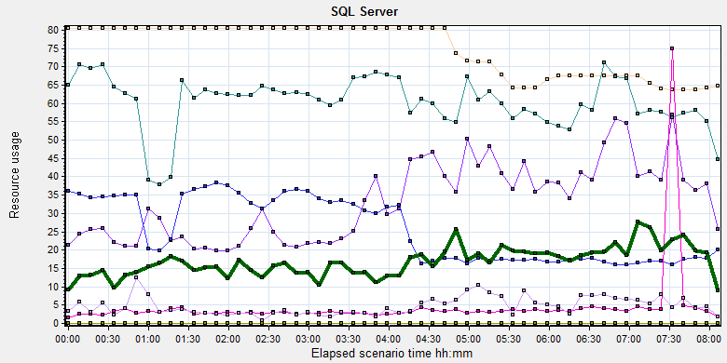
Color | Scale | Measurement | Minimum | Average | Maximum | Std. Deviation
 | 10 | Average Latch Wait Time (ms) (MSSQL$GCPACSWS|Latches):10.184.129.108 | 0.297 | 3.32 | 63.36 | 3.551
 | 1 | Current latch waits (MSOLAP$GCPACSWS|Locks):10.184.129.108 | 0 | 0 | 0 | 0
 | 0.01 | Latch Waits/sec (MSSQL$GCPACSWS|Latches):10.184.129.108 | 107.513 | 2556.56 | 8076.317 | 1314.434
 | 0.01 | Lock Memory (KB) (MSSQL$GCPACSWS|Memory Manager):10.184.129.108 | 6368 | 7496.556 | 8048 | 692.543
 | 1 | Lock Timeouts (timeout > 0)/sec (MSSQL$GCPACSWS|Locks _Total):10.184.129.108 | 0 | 0 | 0 | 0
 | 10 | Lock Timeouts/sec (MSSQL$GCPACSWS|Locks _Total):10.184.129.108 | 0 | 0.452 | 702.118 | 8.814
 | 0.1 | Lock Wait Time (ms) (MSSQL$GCPACSWS|Locks _Total):10.184.129.108 | 0 | 47.474 | 17217.454 | 283.718
 | 1 | Lock waits/sec (MSOLAP$GCPACSWS|Locks):10.184.129.108 | 0 | 0 | 0 | 0
 | 100 | Lock Waits/sec (MSSQL$GCPACSWS|Locks _Total):10.184.129.108 | 0 | 0.169 | 13.106 | 0.341
 | 1 | Number of Deadlocks/sec (MSSQL$GCPACSWS|Locks _Total):10.184.129.108 | 0 | 0 | 0 | 0
 | 1 | Number of SuperLatches (MSSQL$GCPACSWS|Latches):10.184.129.108 | 0 | 0 | 0 | 0
 | 1 | Total deadlocks detected (MSOLAP$GCPACSWS|Locks):10.184.129.108 | 0 | 0 | 0 | 0
 | 0.01 | Total Latch Wait Time (ms) (MSSQL$GCPACSWS|Latches):10.184.129.108 | 359.353 | 6049.325 | 27345.622 | 3493.21

There are 2556 latches every seconds during the testing work (Latch Waits/sec (MSSQL$GCPACSWS|Latches)). That means there are many recourse compete exist in the system. There are also has some locks and lock time out issues. Some SQL statement needs to enhance to fix these issues.
I monitor the database by SQL statement and find the most latch type is ‘CXPACKET’. The root reason is some SQL statement execute time is more than default threshold value 5 seconds. The SQL will execute SQL with multiple threads, there will exist the wait issues. QA team suggests team to enhance the store procedure -wggc.dbo. AFP_SP_GetExamsForSyncToECS performance firstly. If the issues still exist, we should modify the configuration value of database as follow:
Name | Original | Suggest
Cost threshold of parallelism | 5 | 10 or more than 5.
Max degree of parallelism | 0 | Less than number of server
The change of these setting, need more time to verify. There are some SQL statement has the performance issues need to enhance. I will give some suggestion in the append character in the end of document. Please review them and discuss to fix or not thanks.

Test Conclusion
We executed the performance testing scenario for 8 hours. There are 21 errors happened during the testing work. Even some of the final results of them are accepted, but they still caused the issues make the system not health.
The server hardware has some stress. The CPU resource usage is close to the threshold of 85%. Compare with the scenario which the cloud film service is disabled, the CPU usage value is double. It will be a risk for our system.
There are many latches issues and locks exist in our database. The key store procedure for could film service has the performance issues. It cannot meets the requirements.
During the testing works, the attachments upload information as follow:
Type | Count | Size | All
Dicom | 2491 | 9M | 22,419
Dicom Png | 2490 | 1.4M | 3,486
Report Jpg | 1825 | 0.15M | 274
Report PDF | 1825 | 0.12M | 219
 |  |  | 26398 MB
The system uploaded 26.3GB data to server in 8 hours. The result is close to our requirements 30GB. I will add more attachments in next testing work and monitor the result.
Develop team need to fix these issues as soon as possible. QA team will help to team to verify the issues and give more testing works.
The defects and enhancements list as follow:

No. | Type | Descriptions
100048553 | Enhancement | [Performance] The data and log file of ECS database should auto extend with define value not the default one.
100048642 | Defect | [Performance] The upload service will block caused by the SQL statement execute timeout.
100048643 | Defect | [Performance]The print mode and hold time condition in wggc.dbo.sp_getExamsForSyncToECS is wrong.
100048652 | Defect | [Performance]Add index for column SyncToECS on film and report table to enhance performance.
100048653 | Enhancement | [Performance] Add index for column tablename,tablekey,tablevalue on table.Ecs.dbo.UpdateInformation
100048654 | Enhancement | [Performance] Add the index for SQL statement and change the execute rule for forward film and report logic of system.
100048655 | Enhancement | [Performance] Resolve the bookmark lookup issues for SQL statement.

Tune suggestion:
During the testing work we find some SQL statement has performance issues. I collect and give some suggestion to enhance them. The detail information as follow:
- The key store procedure for cloud film upload service:

This SQL will use too many logic read and root cause is the SQL cannot use index to filter the data which column SyncToECS value is 0. The SQL statement execute time is more than 5 seconds and also cause the parallelism issues. From the execute plan we can see this two issues:
92% resource is used to cluster query because the syncToECS column has no index.
I add the index for column syncToECS for report and film table and the execute plan is changed. The performance has a good enhance.

I suggest team to add index to enhance the performance of SQL.

- The trigger SQL:
select top 1 @cdt = [CreateDateTime] from [dbo].[UpdateInformation]
where [TableName] = 'FilmReportStatus' and [TableKey] = 'ExamID' and [TableValue] = @ExamID
order by [CreateDateTime] desc
SET @diff = datediff(second,@cdt,getdate())
if @diff is null OR @diff > 3
INSERT INTO [dbo].[UpdateInformation] (TableName, TableKey, TableValue, CreateDateTime) VALUES('FilmReportStatus', 'ExamID', @ExamID, GETDATE())
The table ‘ecs.dbo. UpdateInformation’ only has cluster key for column ‘updateid’. Suggest add the index for ‘examid’ and include the column ‘createdatetime’.

3. The SQL for forward film or report information:
SELECT JobInstanceUID, ForwardStatus = CASE WHEN ForwardStatus IS NULL THEN -1 ELSE ForwardStatus END,
ForwardFlag = CASE WHEN ForwardFlag IS NULL THEN -1 ELSE ForwardFlag END,ForwardDestination,ModalityType, CallingAE ,CallingIP,PatientName,PatientID,
PatientType = CASE WHEN PatientType IS NULL THEN '' ELSE PatientType END
FROM Printer.dbo.DeliveryJob J INNER JOIN printer.dbo.Session S
ON J.SessionInstanceUID = S.SessionInstanceUID
WHERE J.DeleteStatus = 0 AND (
(ForwardStatus = -1 OR ForwardStatus IS NULL ) OR
(ForwardStatus = 0 AND ForwardFlag = 1)
)
This SQL do not use the index and cause the parallelism issues.
Suggest add index for column sessionInstanceUID on table deliverjob and add index for column DeleteStatus, ForwardStatus on table session.
After add index, this SQL will use index to query data and reduce one parallelism operation. But it still has the lookup query. We can include the lost columns when create the index to resolve this issues. I suggest develop team to check the configuration of system. If the system does not need to forward information, please do not execute this SQL statement. That can reduce the stress for database.

4. These two SQL statements will cause the bookmark lookup query

IF EXISTS(SELECT * FROM dbo.AFP_ExamInfo WHERE AccessionNumber = @AccNO)
if exists(select * from [AFP_FilmInfo]
WHERE ([AccessionNumber] = @AccNO)
and FilmFlag=3
and (DeleteStatus = 0 or DeleteStatus is null)
)
Suggest change ‘Select * from…’ to ‘select [column] from …’ which column is cluster or non-cluster index such as ‘select AccessionNumber from …’.

<End of document>

